**RENTAL HOME SYSTEM**

A project submitted to

**UKA TARSADIA UNIVERSITY**

In partial fulfillment of the requirements for the degree of

**Bachelor of Science**

In

**Information Technology**

For

**5 Years Integrated M.Sc. (IT)**

By

**URVI PATEL**

201706100110143

**TRUSHA SABHADIYA**

201706100110053

Guided by

**MR. HARDIK VYAS**

**Assistant Professor, BMIIT**



**Babu Madhav Institute of Information Technology**

### Uka Tarsadia University

### Bardoli – 394350

### May 2020

**CERTIFICATE**

This is to certify that **Urvi Patel (201706100110143), Trusha Sabhadiya (201706100110053)** has submitted project entitled **“Rental Home System”** as the partial fulfillment for the award of the degree of Master of Science in Information Technology for 5 Years Integrated M.Sc.(IT) in 2019 – 2020.



**Date:**

**Place:**

**Mr. Hardik Vyas Dr. Jitendra Nasriwala**

Guide Programme Coordinator,

Babu Madhav Institute of Information Technology

**External Examiner**



**Babu Madhav Institute of Information Technology,**

**Uka Tarsadia University,**

**Bardoli - 394350**

**Acknowledgement**

We would like to express my deepest gratitude to all those who provided us the possibility to complete this project. It would not have been possible without the kind support and help of many individuals. We would like to extend our sincere thanks to all of them.

We respect and thank Babu Madhav Institute Of Information Technology for providing us an opportunity to do the project work and giving us all support and guidance which made us complete the project duly.

We owe our deep gratitude to our project guide **Mr. Hardik Vyas**, who took keen interest on our project work and guided us all along, till the completion of our project work by providing all the necessary information for developing a good system.

My thanks and appreciations also go to our friends in developing the project and people who have willingly helped us out with their ability.

Urvi Patel [201706100110143]

Trusha Sabhadiya [201706100110053]

**Table of Contents**

1. Introduction 04

1.1 Project Definition 04

* 1. Purpose 05
  2. Scope 04
  3. Design and Implementation Constraints 05
  4. Hardware Interfaces 05
  5. Software Interfaces 06
  6. Communications Interfaces 06

1. System Analysis 07

2.1 Identification of Need 07

2.2 Identification of Stakeholders 07

2.3 Functional Requirement 07

2.4 Non- Functional Requirement 11

2.5 Modules 11

2.6 User Characteristics 15

2.7 Use Case Diagram 16

2.8 Use Case Description 17

2.9 Activity Diagram 19

2.10 Data Dictionary 28

1. User Interface Design 38
2. Testing 63

4.1 Test Cases 63

4.2 Validations 64

1. Future Enhancement 70
2. References/Bibliography 70

6.1 References 70

6.2 Bibliography 70

1. **Introduction**
   1. **Project Definition**

The Rental Home System is a web based application being developed will provide an online platform. There are three users of the system admin, property owner and tenants. This system allows admin to login into the system and is able to activate or deactivate the users. The admin is able to view the details of the property on rent and generate the report accordingly. The property owner registered into the system in order to use the functionalities of the system after login. The property owner insert the property details to give on rent to the tenants. The property owner can give feedback to make changes in the system. After proper registration and login tenants can view the property details and it tenants wants to take any property on rent the tenant need to request to the property owner for the same. If property owner accepts the request coming from the tenant, tenants can further go for booking process. To finalize the rental property the tenants need to accept terms and conditions and pay deposit and one month rent to the admin. Before leasing out property the tenants need to notify before one month to the property owner and if the property owner accepts the same than the tenant will get refund of the deposit. The tenants can make complain for the property.

* 1. **Purpose**

The purpose of the system is the tenants can view the property without physically being present. The system also saves time and it is also economical.

* 1. **Scope**
* The system provides facilities only to the registered users. The renting facility is provided by the system only in the localities of Surat.
  1. **Design and implementation constraints**
* This system is implemented in PHP.
* The designing is done in CSS and Bootstrap.
* The information is stored in MySQL database where data cannot be shared in global database.
  1. **Hardware interfaces**
* **Processor:**

Intel core i5

* **Hard Disk:**

1TB Disk Space or Higher

* **Memory:**

2GB Ram or Higher

* 1. **Software interfaces**

**Front-end:**

* + Bootstrap
  + HTML
  + CSS
  + JQUERY

**Back-end:**

* PHP, MySQL as Database

**Technologies:**

* Umlet
* Xampp Server
* NetBeans
  1. **Communications Interfaces**

• **HTTP**:Hypertext Transfer Protocol

• **Web browser**

• **MySQL**

• **SMTP MAIL**

1. **System Analysis**
   1. **Identification of need**

* The tenants can view the property without physically being present.
* To expand Real Estate Business in market.
* It saves time.
  1. **Identification of stakeholders**

**Following are the stakeholders of the system:**

* **Admin**
* **Tenant**
* **Property Owner**
  1. **Functional requirements**
* **Registration:**

The system shall be able to register all the owner and tenants. The registration details of users will be stored into the database. The system will then allow those registered users to login into the system.

The tenant can register themselves and the property owner will be registered by the admin. The property owner will be registered by the admin by accepting the request. Following information is required for registration:

For property owner:

* Owner name
* Address
* State
* City
* Contact no
* Emailid
* Adharcard photo
* Pan card photo
* Profile photo

For Tenants:

* Tenant name
* Address
* State
* City
* Contact no
* Emailid
* Adharcard photo
* Pan card photo
* Profile photo
* **Login:**

The system shall be able to allow the owner, tenants and admin to login into the system, by checking the authentication on the basis of email id and password entered by them.

* **Forgot Password:**

Users can change their password if they forget. To set new password, OTP will be sent to user's email id. After which the user can set new password.

* **Change Password:**

User can change their password where they need to enter their old password and if it matches with the current password, then the new password will be asked and changed.

* **Activate and Deactivate User:**

The admin shall be able to activate the new user and deactivate the users who have deleted their account. The admin can also deactivate the account of any user if found suspicious.

* **Send Mail:**

Whenever the users successfully registered into the system they will be receiving an email.

* **Update Profile:**

The owner and tenants and admin shall be able to update profile based on his/her specification.

* **Delete Account:**

The owner and tenants and admin shall be able to delete the existing details.

* **Add/Update/Delete Property Detail:**

The property owner shall be able to add photos and other necessary property details and update/delete the existing details.

* **Search Property Detail:**

The tenants shall be able to search property based on his/her specification.

* **Pay Deposit and Rent:**

To finalize the rental property the tenants need to accept terms and conditions and pay deposit and one month rent to the admin.

* **Reserve Property:**

For the tenants confirm the booking they need to provide deposit and rent to the admin and all the necessary details with accepting the terms and conditions.

* **Generate PDF:**

The system shall be able to generate pdf after successful payment of the deposit and rent.

* **Send Notification:**

After proper registration and login tenants can view the property details and it tenants wants to take any property on rent the tenant need to request to the property owner for the same. If property owner accepts the request coming from the tenant, tenants can further go for booking process.

* **Take Commission:**

The admin shall be able to take commission once the tenants and owner confirm with the rent.

* **Refund Deposit:**

Before leasing out property the tenants need to notify before one month to the property owner and if the property owner accepts the same than the tenant will get refund of the deposit.

* **Add/Update Complain:**

The tenants and property owner shall be able to add complain of the property and also update the existing complain.

* **Give Feedback:**

The tenants shall be able to give the feedback for the property and owner shall be able to give the feedback for the system.

* **Reports:**

The system shall be able to generate report of the total number of the user registered, number of property which is already rented and the remaining properties.

Following reports are there:

* + - * + Details of property owner registered
        + Details of tenant registered
        + Details of lease property
        + Details of lease out property
        + Details of pay rent & deposit
  1. **Non-Functional Requirements**
* **Security:** For securing the user's password, MD5 encryption algorithm will be used.
* **Responsive:** Bootstrap will be used to develop the system device-friend.
  1. **Modules**
* **Registration and Login**

The module has following functionalities:

* + - * + Registration
        + login
        + Activate and deactivate user
        + Send mail and SMS
        + Forgot password

The tenant and the property owner will first get registered by providing the necessary details. A message successful registered will be sent to their email address and their account will get verified. The property owner will be registered by the admin by accepting the request. After registration, the users can log into the system. Login page will ask the users to enter their username and password. If the username and password is valid, then he/she will be redirected to the home page. If they forget the password, a new password will be set by sending an email and verifying the OTP and replacing the old password with the new password. Users can also temporarily deactivate their accounts, so that their profile is not visible on the website. The admin can also deactivate the account of any user if found suspicious.

* **Build Profile**

The module has following functionalities:

* + - * + Change password
        + Update profile
        + Delete account

The tenant and property owner can create their profile by entering required details and upload it on the website. They can also edit the profile as per their needs. They can change their passwords if they need to, by entering old password and after its verification, they can set the new password.

* **Manage property Details**

The module has following functionalities:

* + - * + Add property details
        + Update property details
        + Delete property details
        + Search property details

The property owner shall be able to add photos and other necessary property details and update/delete the existing details. The tenants shall be able to search property based on his/her specification.

* **Manage Booking**

The module has following functionalities:

* + - * + Send notification
        + Pay deposit and rent
        + Generate PDF
        + Reserve property

After proper registration and login tenants can view the property details and it tenants wants to take any property on rent the tenant need to request to the property owner for the same. If property owner accepts the request coming from the tenant, tenants can further go for booking process. To finalize the rental property the tenants need to accept terms and conditions and pay deposit and one month rent to the admin. The system shall be able to generate pdf after successful payment of the deposit and rent.

* **Lease Out Property**

The module has following functionalities:

* + - * + Take commission
        + Refund deposit

The admin shall be able to take commission once the tenants and owner confirm with the rent. Before leasing out property the tenants need to notify before one month to the property owner and if the property owner accepts the same than the tenant will get refund of the deposit. The tenants can make complain for the property.

* **Manage Complains**

The module has following functionalities:

* + - * + Add complain
        + Update complain

The tenants and owner shall be able to add complain of the property and also update the existing complain.

* **Reports:**

Reports of the following shall be available:

* + - * + Details of property owner registered
        + Details of tenant registered
        + Details of lease property
        + Details of lease out property
        + Details of pay rent & deposit
  + **Feedback:**

The tenants shall be able to give the feedback for the property and owner shall be able to give the feedback for the system.

* 1. **User Characteristics** 
     1. **Admin:**
* Admin can login into the system.
* Admin can view details of registered users.
* Admin can activate and deactivate the users.
* Admin can view the details of the property on rent.
* Admin can generate report.
* Admin can view feedback.
  + 1. **Property Owner:**
* Property owner can register into the system.
* Property owner can login into the system.
* Property owner can manage its profile.
* Property owner can add property details to give on rent to the tenants.
* Property owner can give feedback of the system.
* Property owner can view the tenant’s feedback.
* Property owner can accept or reject request of the tenant for rent property.
* Property owner can view complain of the tenant for rent property.
  + 1. **Tenants:**
* Tenants can register into the system.
* Tenants can login into the system.
* Tenants can manage its profile.
* Tenants can give feedback of the system.
* Tenants can request to the property owner for the rent property.
* Tenants can pay deposit and monthly rent through the system.
* Tenants can make complain for the property.
  1. **Use Case Diagram**

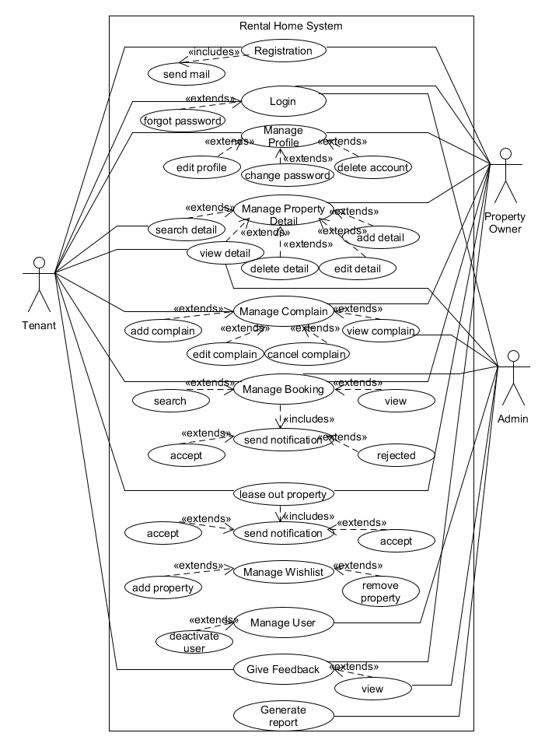

* 1. **Use Case Description**

|  |
| --- |
| **Introduction**  The use case document depicts the steps that must be followed for Manage Profile. |
| **Actors**  Admin  Property Owner  Tenant |
| **Pre-condition**  Property Owner, tenants and the admin must log into the system to manage their profiles. |
| **Post-condition**  If the use case is successful, the user will be redirected to the same page with updated records. |
| **Event Flow**  ***Basic Flow:*** Users will be on the same page with updated records. |
| **Alternative Flow:** 1. Invalid credentials  If the data being inserted are invalid, the user will be prompted by an error message of invalid values. |
| **Special Requirement**  None |
| **Associated Use Case**  Login |

|  |
| --- |
| **Introduction**  The use case document depicts the steps that must be followed for Rental Home System. |
| **Actors**  Property Owner  Tenant |
| **Pre-condition**  1. Property owner, tenant and the admin must log into the system.  2. Tenant must have entered the required details for rent property. |
| **Post-condition**  If the use case is successful, the property owner status will be changed to lease and booking property will be confirmed. |
| **Event Flow**  ***Basic Flow:*** system will change property status after pay rent and deposit of rent property and admin will also be able to view the results. |
| **Alternative Flow:** 1. Invalid credentials  If the data being inserted are invalid, the user will be prompted by an error message of invalid values. And if the selected property is not available tenant will be promoted by error message. |
| **Special Requirement**  None |
| **Associated Use Case**  Login  Manage Property Booking |

* 1. **Activity Diagram** 
     1. **Activity Diagram for Login:**

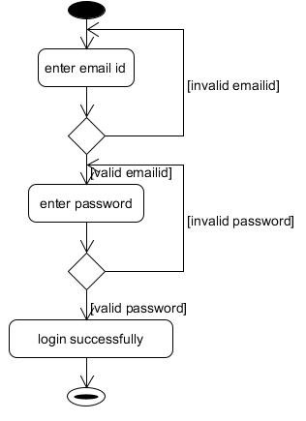

* + 1. **Activity Diagram for Registration:**

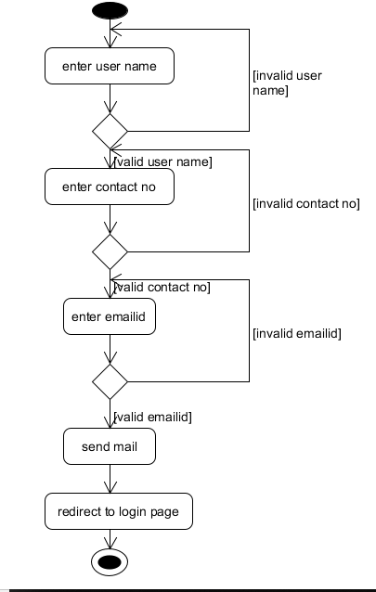

* + 1. **Activity Diagram for Change Password:**

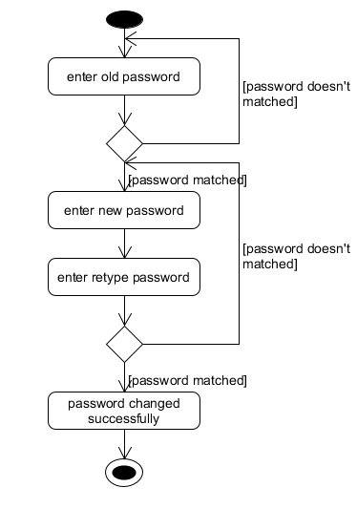

* + 1. **Activity Diagram for Forgot Password:**

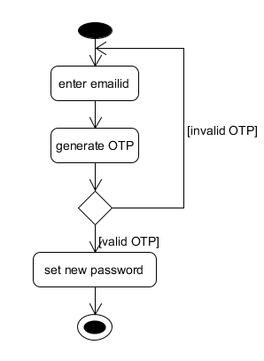

* + 1. **Activity Diagram for Manage Profile:**

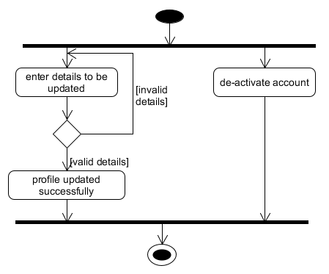

* + 1. **Activity Diagram for Manage Property Detail:**

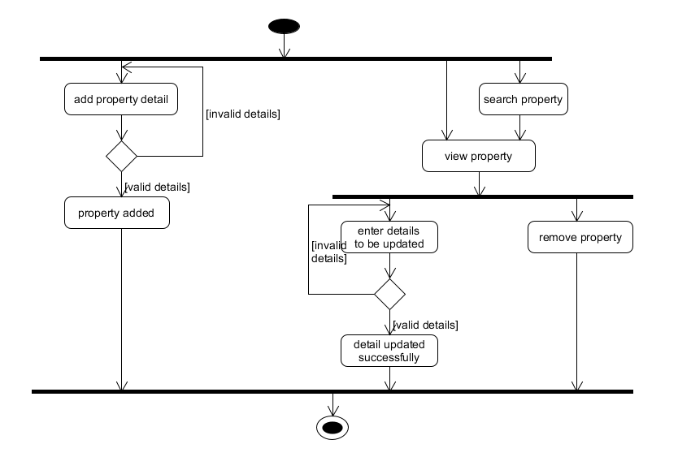

* + 1. **Activity Diagram for Manage Booking:**

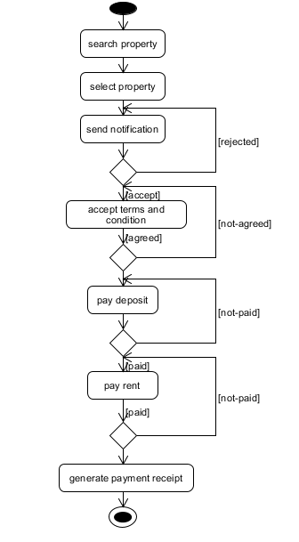

* + 1. **Activity Diagram for Lease Out Property:**

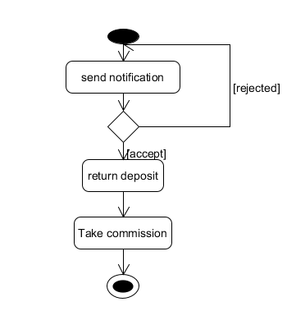

* + 1. **Activity Diagram for Manage Complain:**

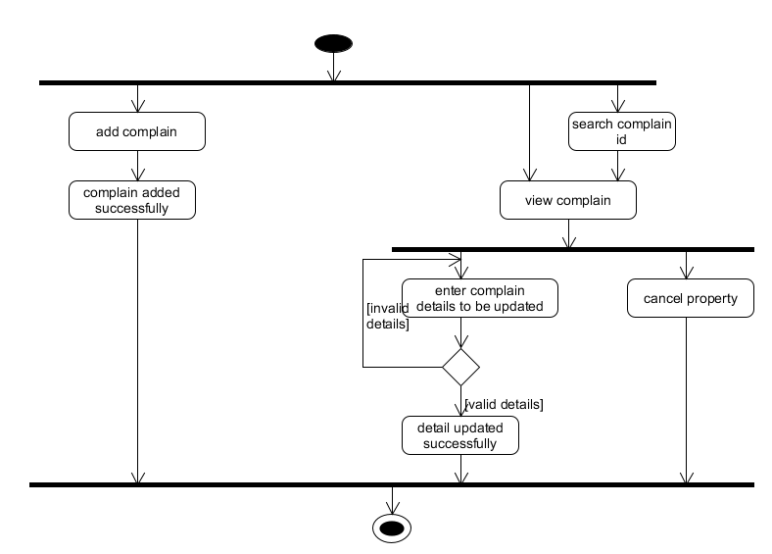

* 1. **Data Dictionary** 
     1. **Tbl_Property_Owner:**

|  |  |  |  |  |  |
| --- | --- | --- | --- | --- | --- |
| **Field Name** | **Datatype** | **Allow Null** | **Key** | **Extra** | **Description** |
| OwnerId | tinyint | no | Primary key | Auto Increment |  |
| OwnerName | varchar(25) | no |  |  |  |
| Address | varchar(50) | no |  |  |  |
| StateId | tinyint | no | Foreign key |  |  |
| CityId | tinyint | no | Foreign key |  |  |
| ContactNo | char(10) | no |  |  |  |
| EmailId | varchar(30) | no |  |  |  |
| AadharCardNo | char(14) | no |  |  |  |
| PancardNo | varchar(20) | no |  |  |  |
| OwnerPhoto | varchar(15) | no |  |  |  |

* + 1. **Tbl_Tenants:**

|  |  |  |  |  |  |
| --- | --- | --- | --- | --- | --- |
| **Field Name** | **Datatype** | **Allow Null** | **Key** | **Extra** | **Description** |
| TenantId | tinyint | no | Primary key | Auto Increment |  |
| TenantName | varchar(25) | no |  |  |  |
| Address | varchar(50) | no |  |  |  |
| StateId | tinyint | no | Foreign key |  |  |
| CityId | tinyint | no | Foreign key |  |  |
| ContactNo | char(10) | no |  |  |  |
| EmailId | varchar(30) | no |  |  |  |
| AadharCardNo | char(14) | no |  |  |  |
| PancardNo | varchar(20) | no |  |  |  |
| OwnerPhoto | varchar(15) | no |  |  |  |

* + 1. **Tbl_User:**

|  |  |  |  |  |  |
| --- | --- | --- | --- | --- | --- |
| **Field Name** | **Datatype** | **Allow Null** | **Key** | **Extra** | Description |
| UserId | tinyint | no | Primary key | Auto Increment |  |
| Username | varchar(30) | no |  |  | Email Id |
| Password | varchar(32) | no |  |  |  |
| Status | bit | no |  |  | 0 – Activate  1 - Deactivate |
| OwnerId | tinyint | yes | Foreign Key |  |  |
| TenantId | tinyint | yes | Foreign Key |  |  |

* + 1. **Tbl_Property_Detail:**

|  |  |  |  |  |  |
| --- | --- | --- | --- | --- | --- |
| **Field Name** | **Datatype** | **Allow Null** | **Key** | **Extra** | Description |
| PropertyId | tinyint | no | Primary Key | Auto Increment |  |
| HomeNo | varchar(5) | no |  |  |  |
| SocityName | varchar(25) | no |  |  |  |
| Landmark | varchar(30) | no |  |  |  |
| AreaName | varchar(20) | no |  |  |  |
| DepositAmount | int | no |  |  |  |
| RentAmount | int | no |  |  |  |
| SquareFeet | varchar(7) | no |  |  |  |
| Furnished | bit | no |  |  | 0 - Yes  1 - No |
| OwnerId | tinyint | no | Foreign Key |  |  |

|  |  |  |  |  |  |
| --- | --- | --- | --- | --- | --- |
| **Field Name** | **Datatype** | **Allow Null** | **Key** | **Extra** | **Description** |
| NoOfRooms | tinyint | no |  |  |  |
| NoOfBalcony | tinyint | yes |  |  |  |
| NoOfBathrooms | tinyint | no |  |  |  |
| Photo1 | varchar(15) | no |  |  |  |
| Photo2 | varchar(15) | no |  |  |  |
| Photo3 | varchar(15) | no |  |  |  |
| Photo4 | varchar(15) | no |  |  |  |
| Photo5 | varchar(15) | no |  |  |  |
| Status | bit | no |  |  | 0 – lease 1- lease out |
| HomeType | varchar(10) | no |  |  | Apartment, House, Farm |

* + 1. **Tbl_Complain:**

|  |  |  |  |  |  |
| --- | --- | --- | --- | --- | --- |
| **Field Name** | **Datatype** | **Allow Null** | **Key** | **Extra** | **Description** |
| ComplainId | tinyint | no | Primary Key | Auto Increment |  |
| ComplainDate | date | no |  |  |  |
| ComplainBody | varchar(100) | no |  |  |  |
| OwnerId | tinyint | no | Foreign Key |  |  |
| TenantId | tinyint | no | Foreign Key |  |  |

* + 1. **Tbl_State:**

|  |  |  |  |  |  |
| --- | --- | --- | --- | --- | --- |
| **Field Name** | **Datatype** | **Allow Null** | **Key** | **Extra** | **Description** |
| State_id | tinyint | no | Primary Key | Auto Increment |  |
| StateName | varchar(20) | no |  |  |  |

* + 1. **Tbl_City:**

|  |  |  |  |  |  |
| --- | --- | --- | --- | --- | --- |
| **Field Name** | **Datatype** | **Allow Null** | **Key** | **Extra** | **Description** |
| CityId | tinyint | no | Primary Key | Auto Increment |  |
| CityName | varchar(25) | no |  |  |  |
| StateId | tinyint | no | Foreign Key |  |  |

* + 1. **Tbl_feedback:**

|  |  |  |  |  |  |
| --- | --- | --- | --- | --- | --- |
| **Field Name** | **Datatype** | **Allow Null** | **Key** | **Extra** | **Description** |
| FeedbackId | tinyint | no | Primary Key | Auto Increment |  |
| FeedbackDate | date | no |  |  |  |
| FeedbackBody | varchar(100) | no |  |  |  |
| OwnerId | tinyint | yes | Foreign Key |  |  |
| TenantId | tinyint | yes | Foreign Key |  |  |

* + 1. **Tbl_Booking:**

|  |  |  |  |  |  |
| --- | --- | --- | --- | --- | --- |
| **Field Name** | **Datatype** | **Allow Null** | **Key** | **Extra** | **Description** |
| BookingId | tinyint | no | Primary Key | Auto Increment |  |
| TenantId | tinyint | no | Foreign Key |  |  |
| OwnerId | tinyint | no | Foreign Key |  |  |
| PropertyId | tinyint | no | Foreign Key |  |  |
| BookingDate | date | no |  |  |  |

* + 1. **Tbl_Payment:**

|  |  |  |  |  |  |
| --- | --- | --- | --- | --- | --- |
| **Field Name** | **Datatype** | **Allow Null** | **Key** | **Extra** | **Description** |
| PaymentId | tinyint | no | Primary Key | Auto Increment |  |
| BookingId | tinyint | no | Foreign Key |  |  |
| PaymentDate | date | no |  |  |  |
| PaymentAmount | Float | no |  |  |  |

* + 1. **Tbl_Notification:**

|  |  |  |  |  |  |
| --- | --- | --- | --- | --- | --- |
| **Field Name** | **Datatype** | **Allow Null** | **Key** | **Extra** | **Description** |
| NotificationId | tinyint | no | Primary Key | Auto Increment |  |
| TenantId | tinyint | no | Foreign Key |  |  |
| OwnerId | tinyint | no | Foreign Key |  |  |
| NotificationBody | varchar(50) | no |  |  |  |
| Status | bit | no |  |  | 0 – accept  1 – reject |

1. **User Interface Design**
   1. 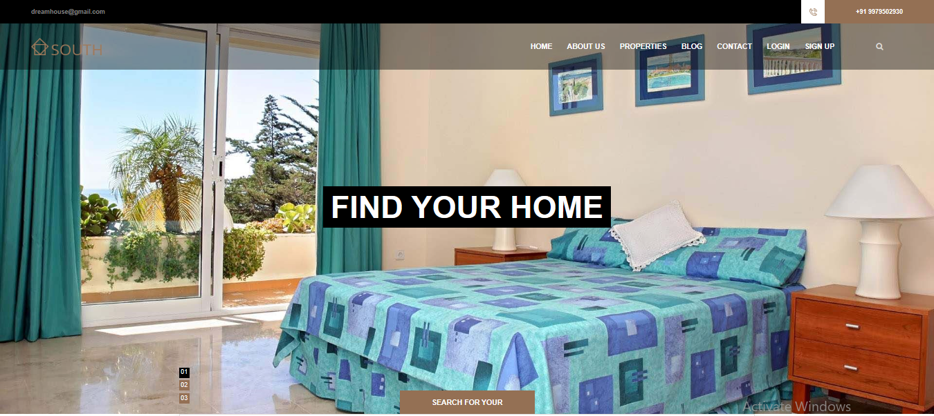**Home**

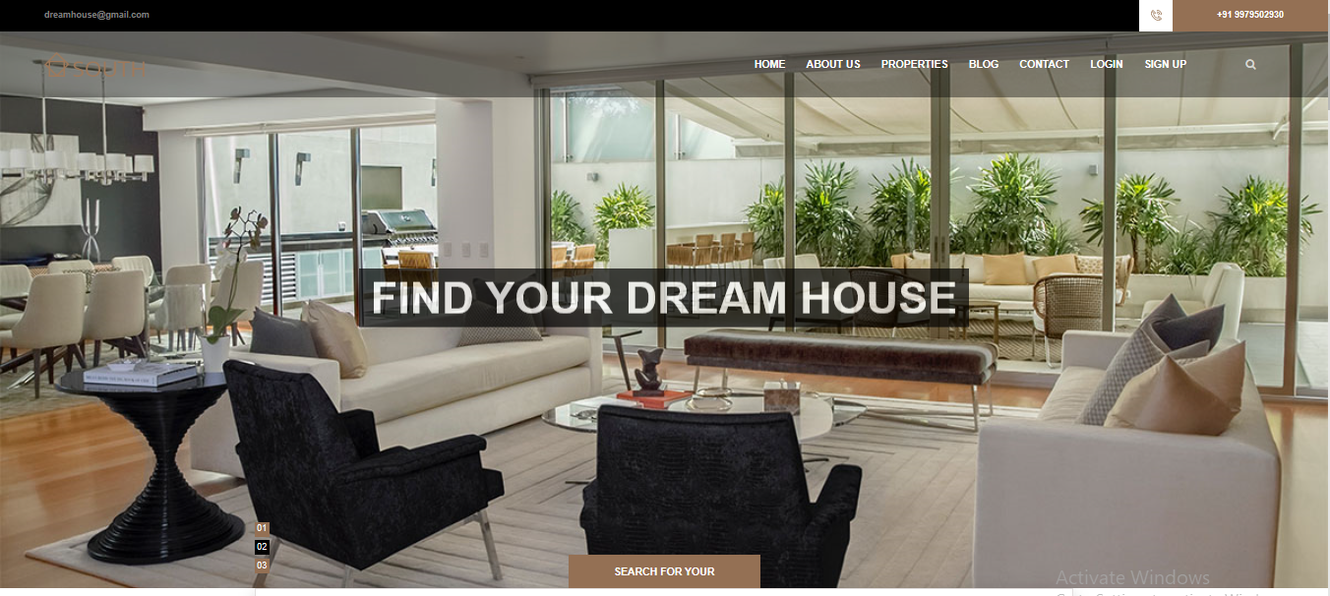

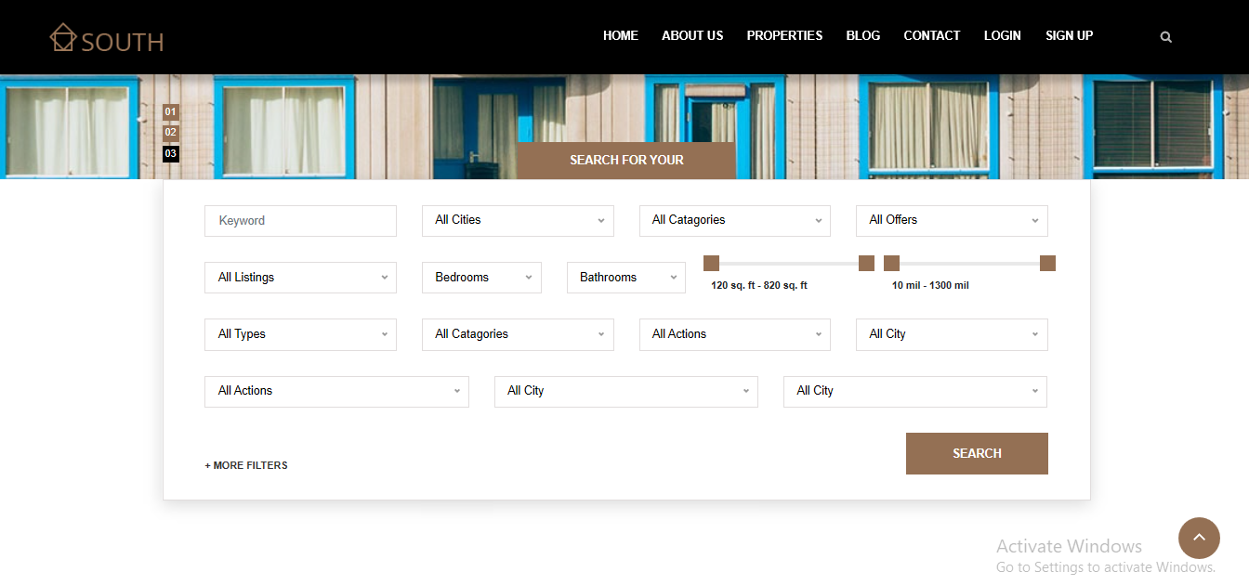

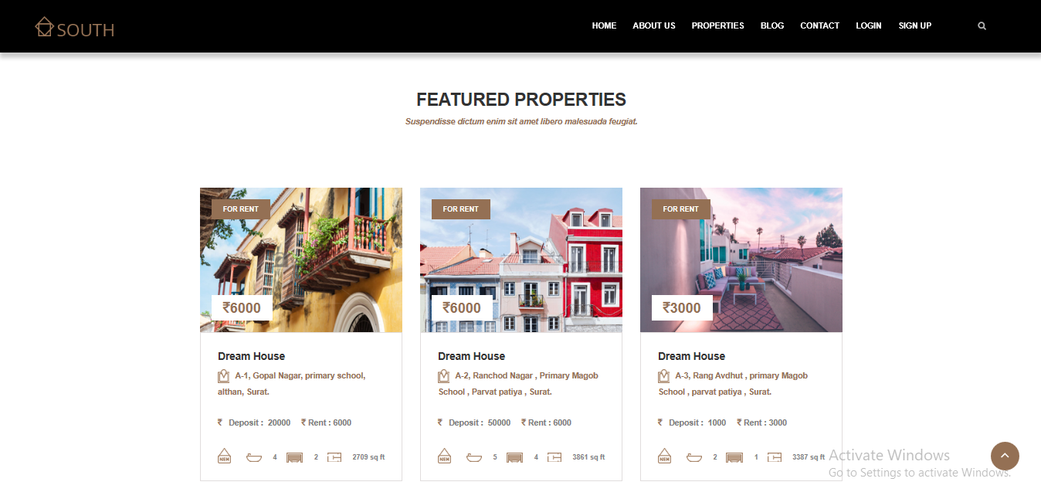

* 1. **Registration**

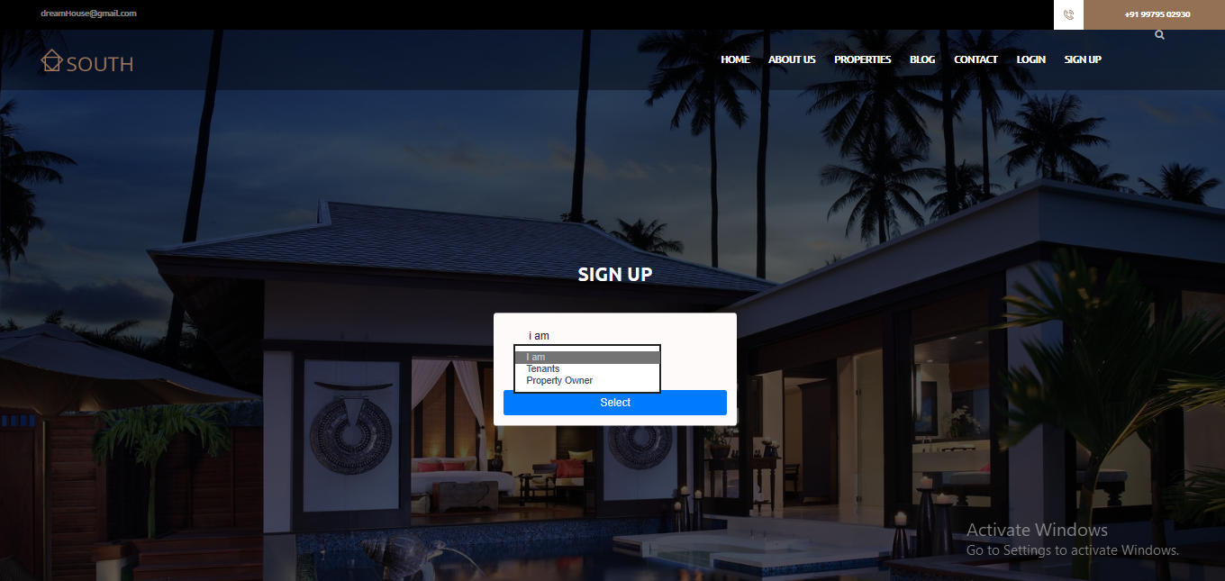

* + 1. **Tenant**

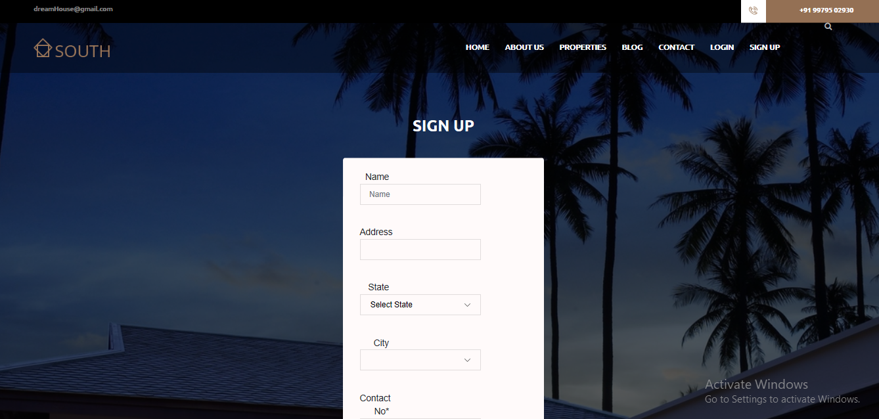

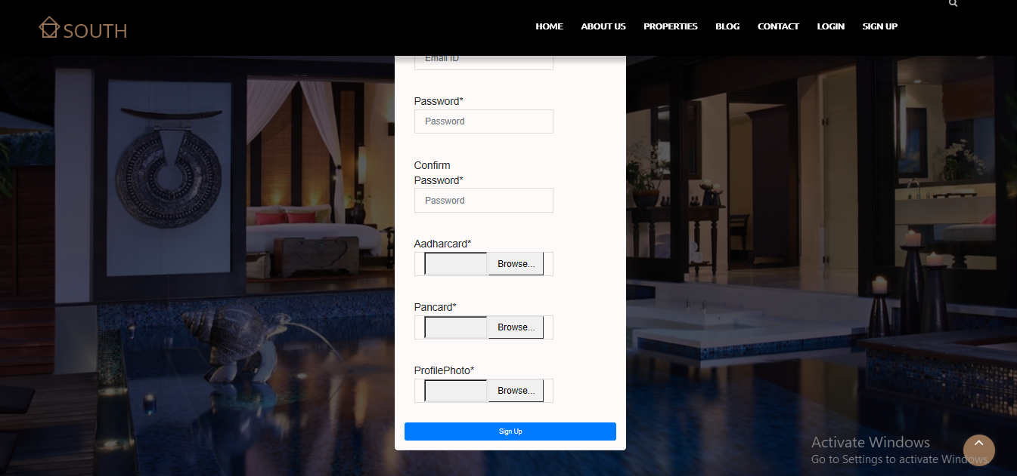

* + 1. 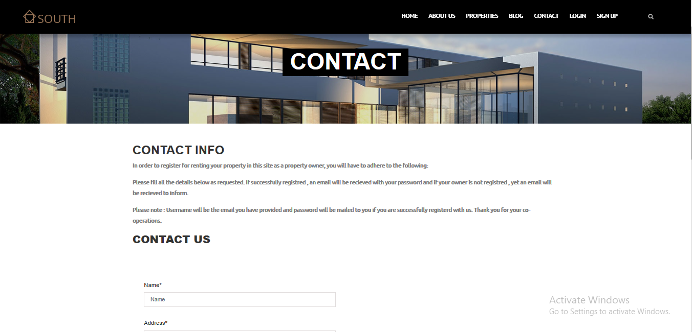**Property Owner**

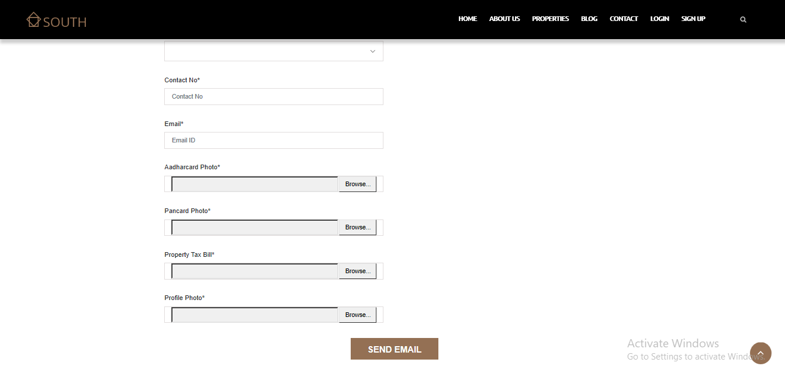

* 1. **Login**

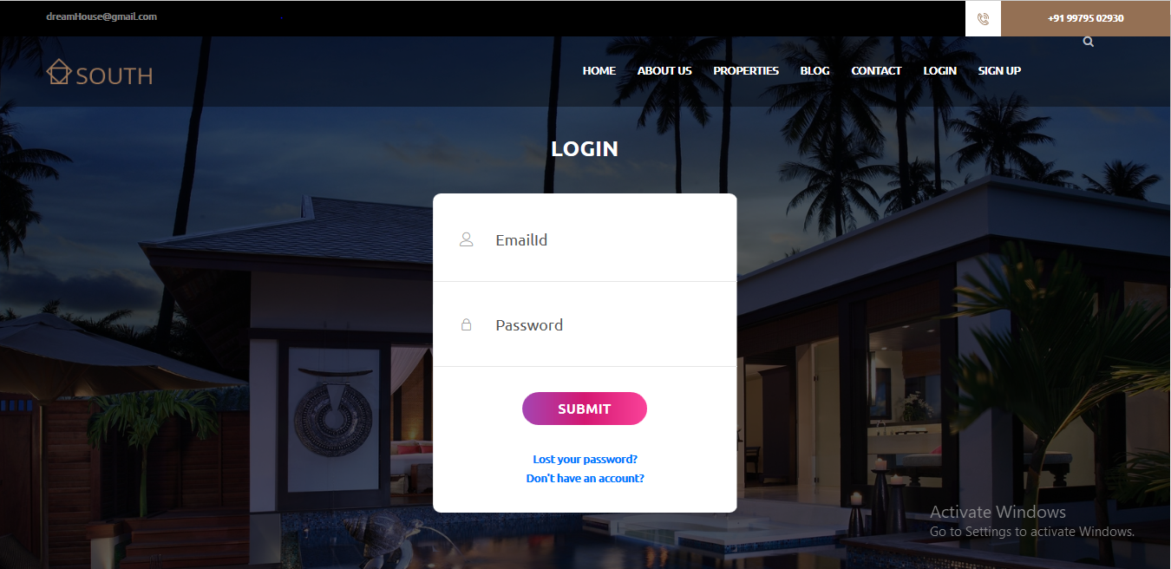

* 1. **Forgot Password**

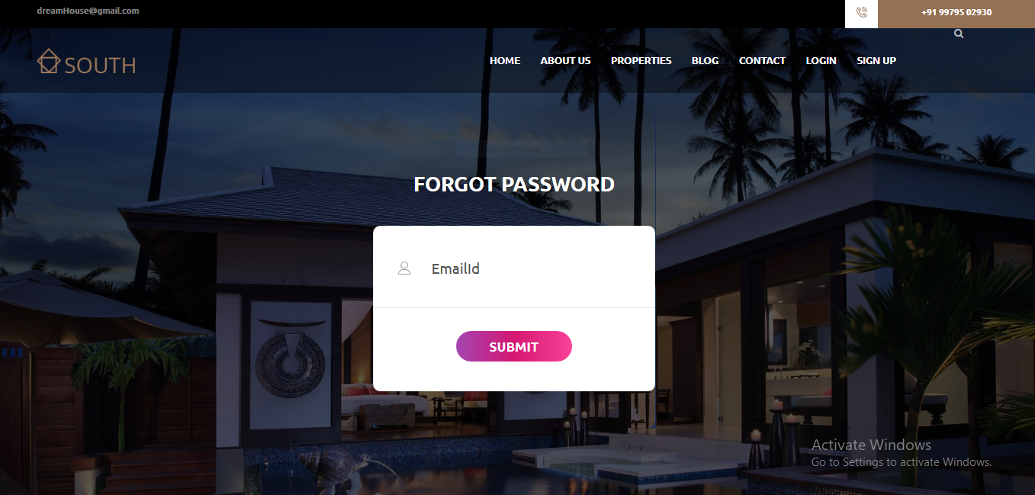

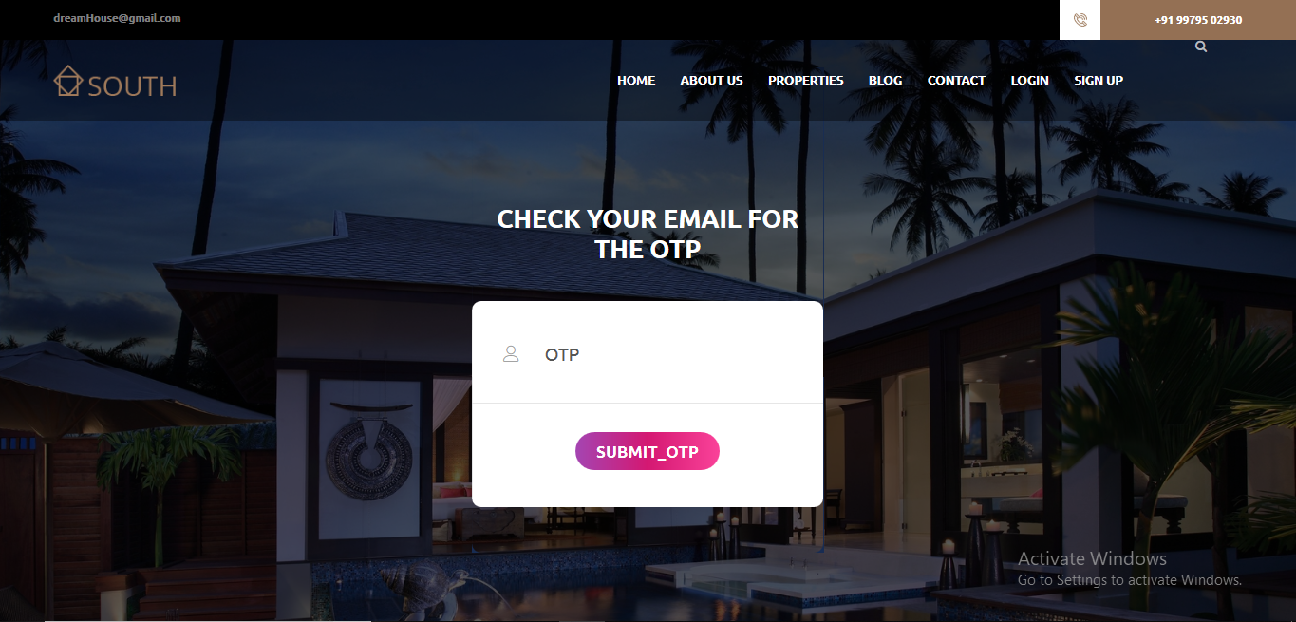

* 1. **Send OTP via User Emailid**

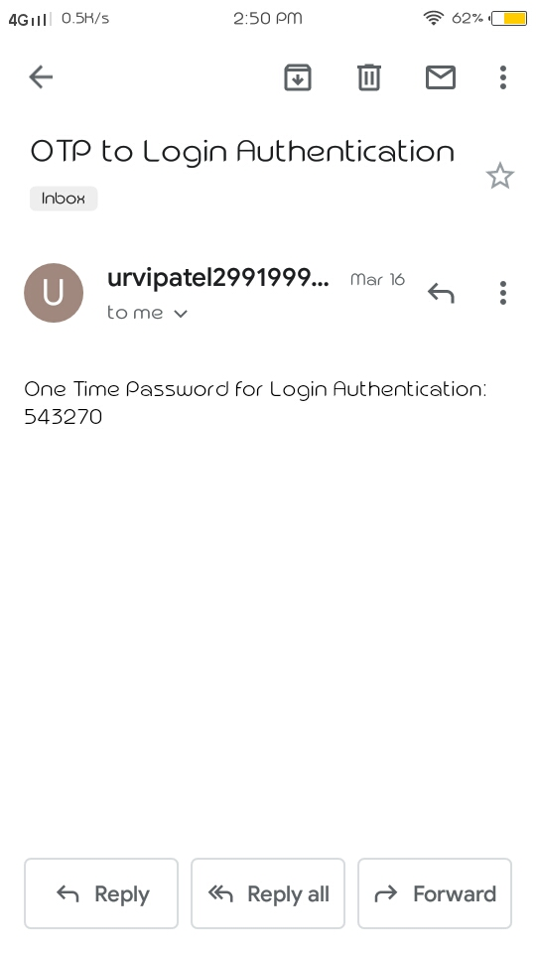

* 1. 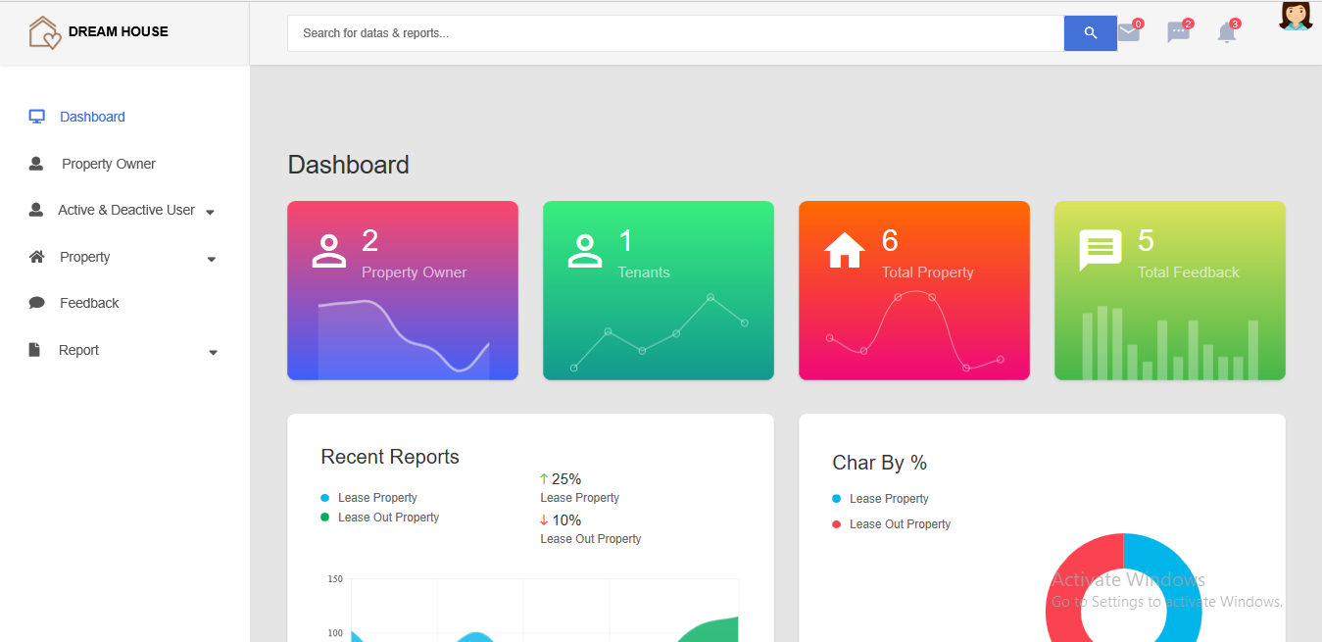**Admin Dashboard & Profile**

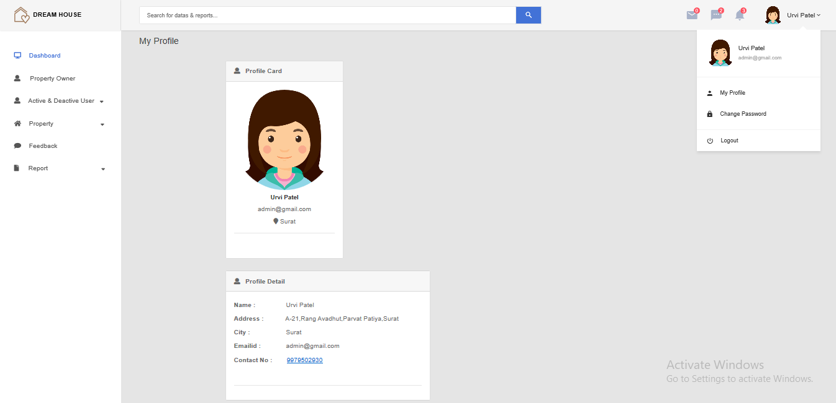

* 1. 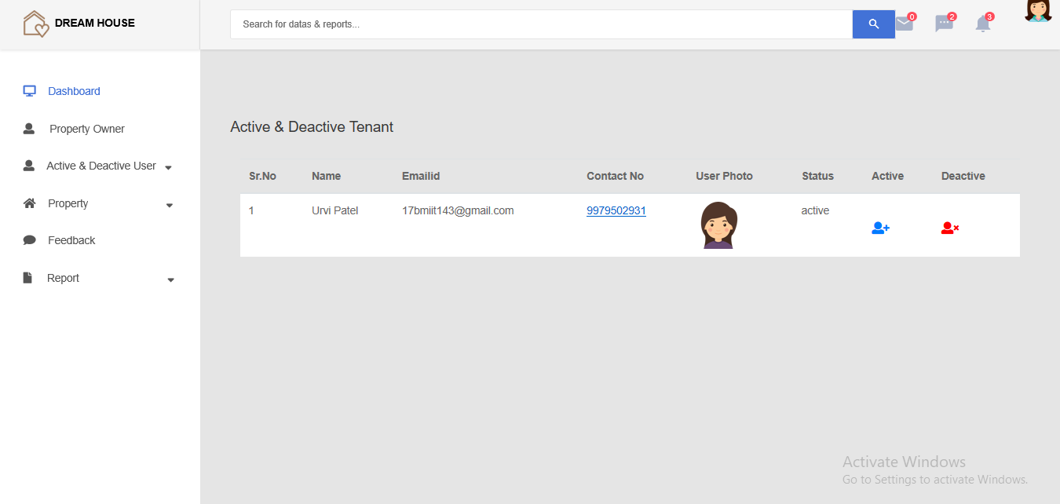**Activate & Deactivate User by(Admin)**

* 1. 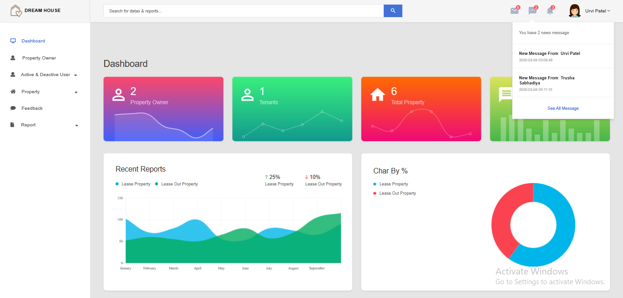**Notification**
  2. **Reports**
     1. 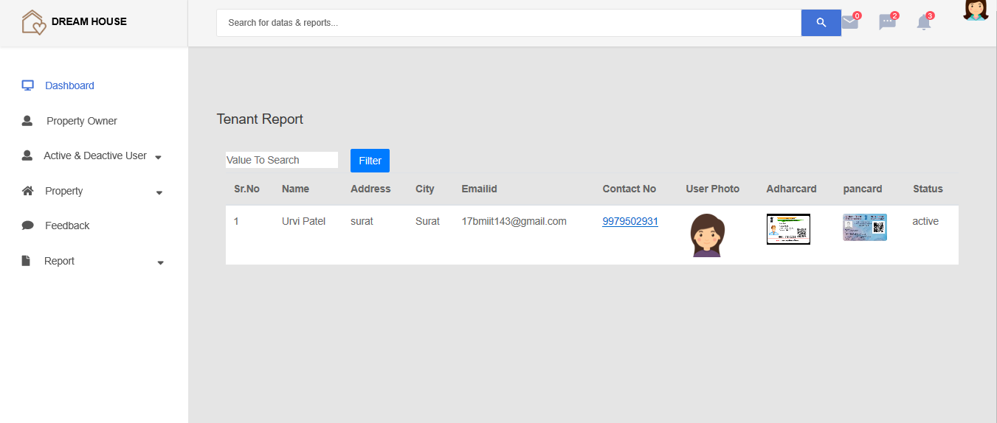**Details of tenants registered**
     2. **Details of property owner registered**

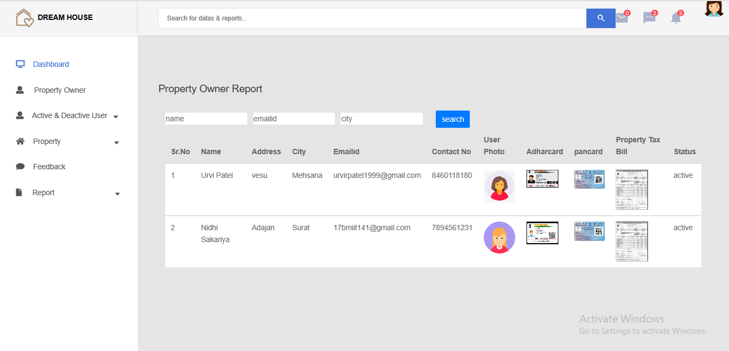

* 1. **Accept & Reject Property Owner by Admin**

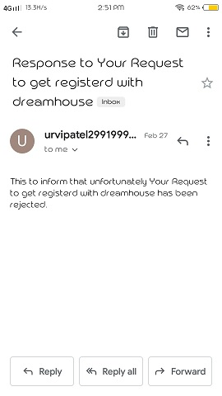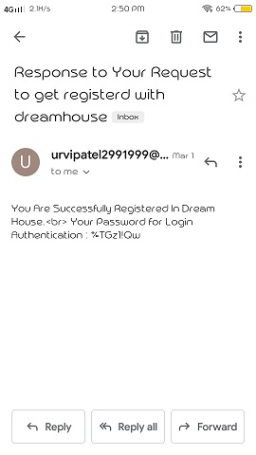

* 1. 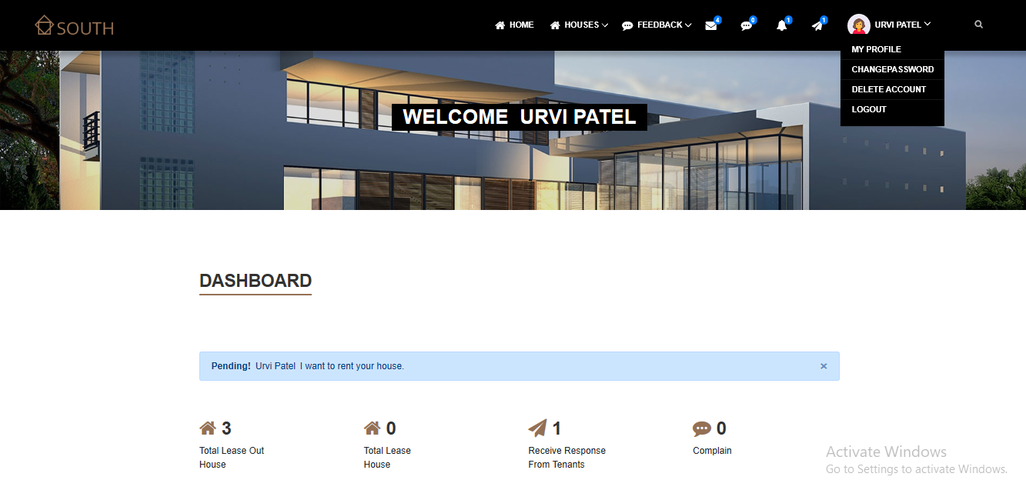**Property Owner Dashboard & Profile**

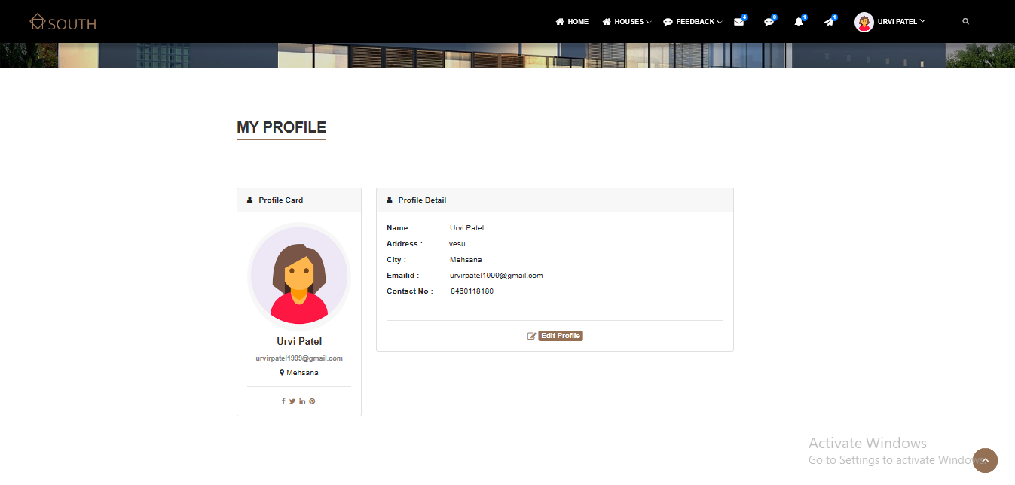

* 1. **Add Property Details**

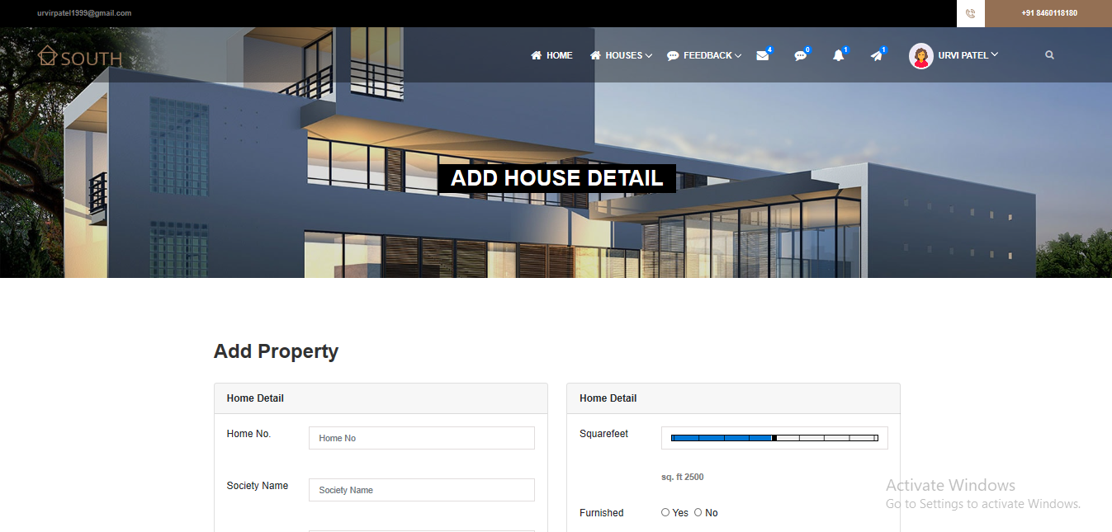

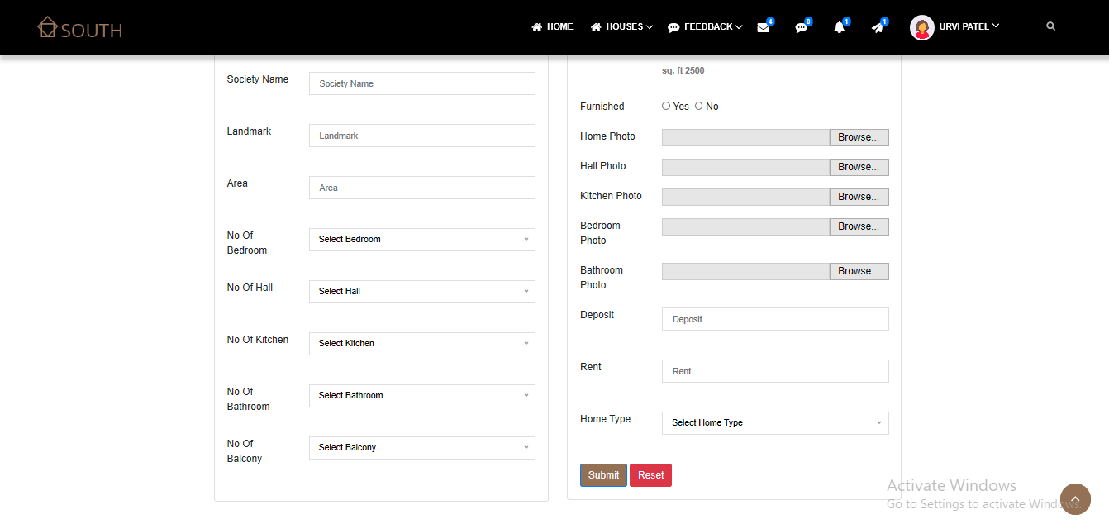

* 1. **Receive Notification**

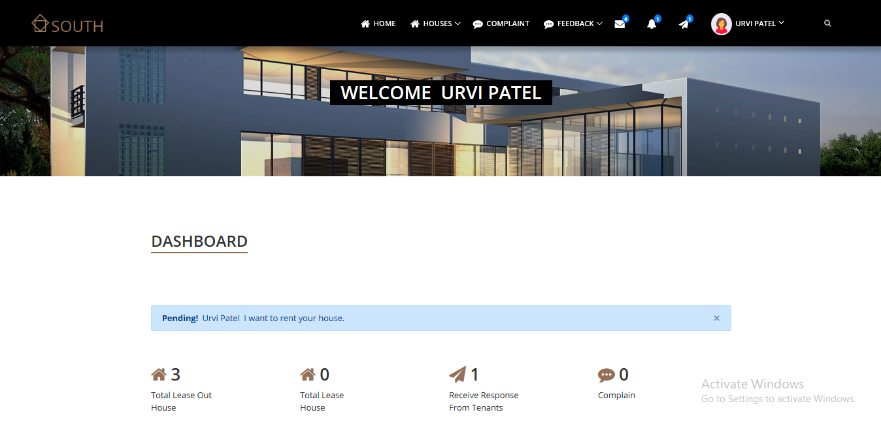

* 1. 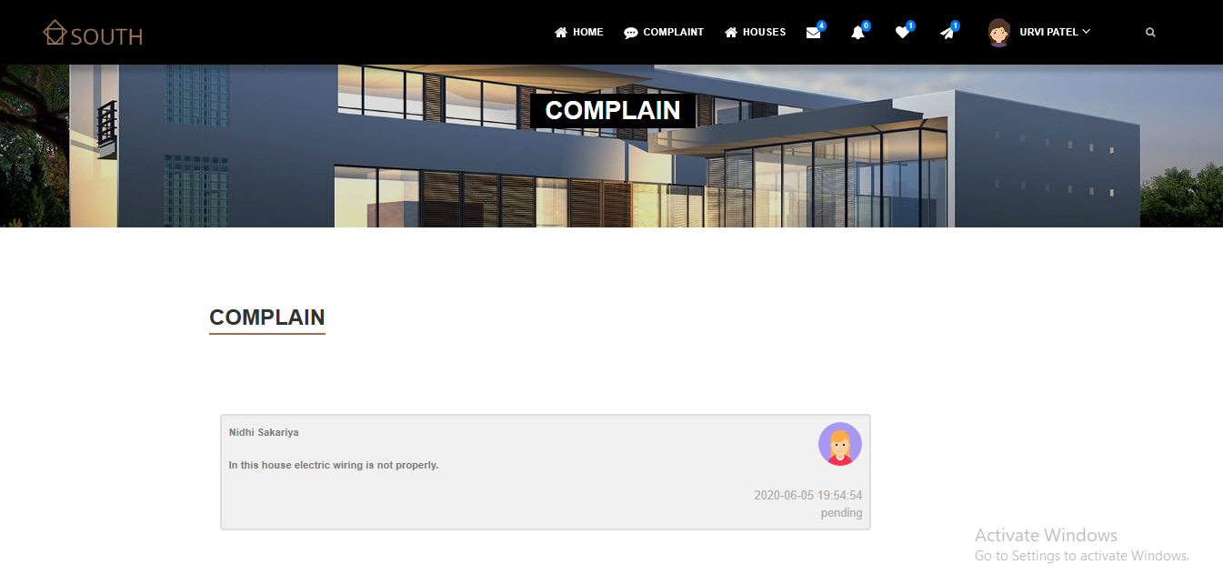**Show Complaint**
  2. **Tenants Request for Property**

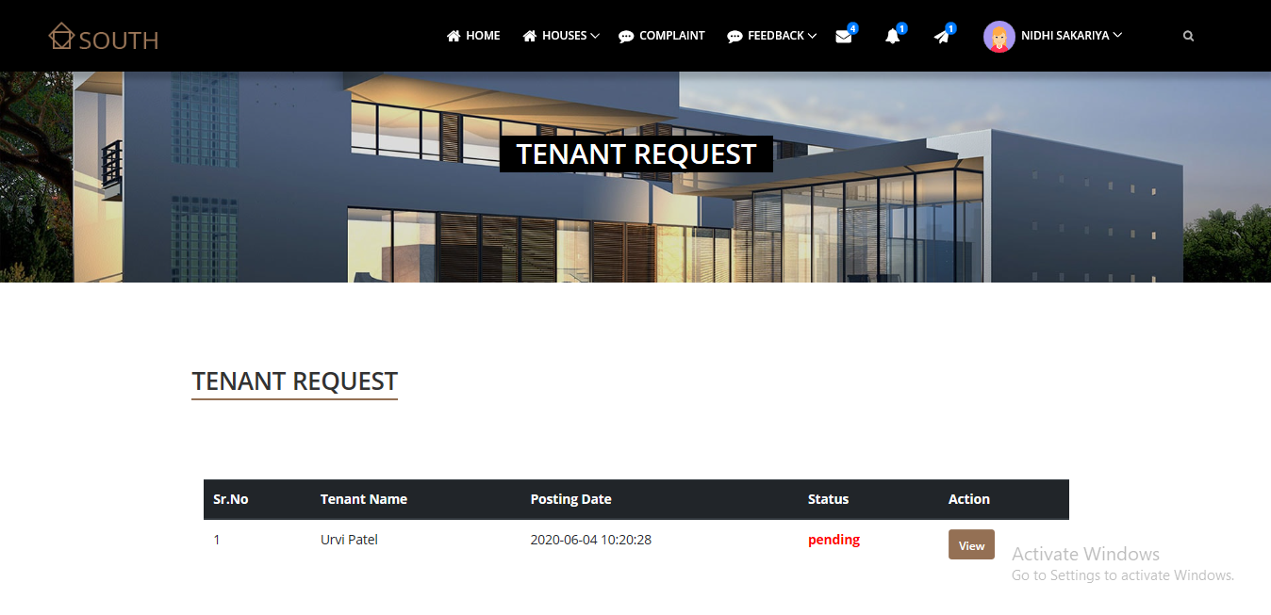

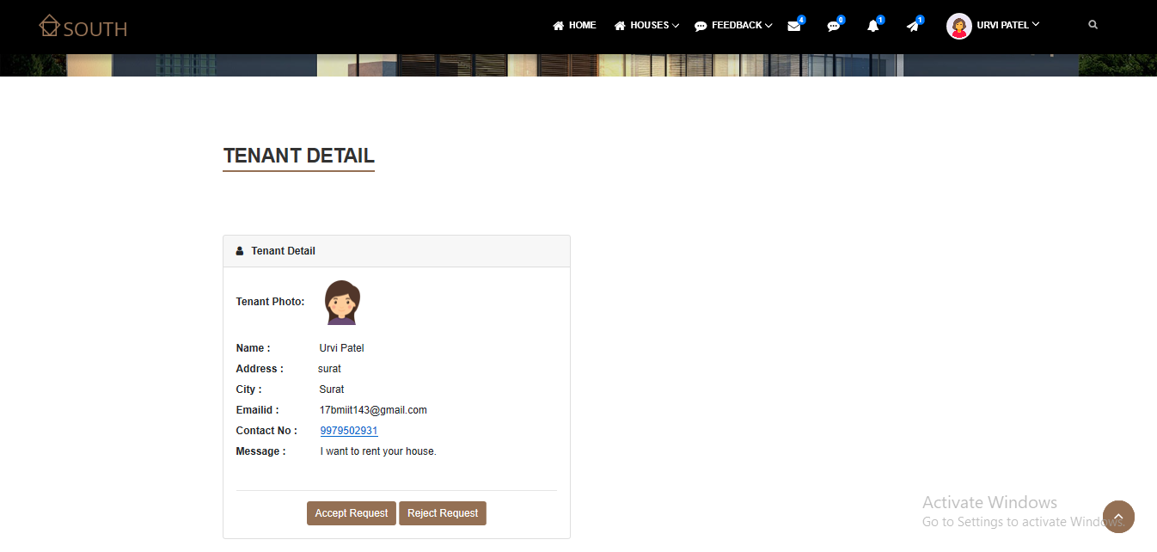

* 1. **Tenant Dashboard & Profile**

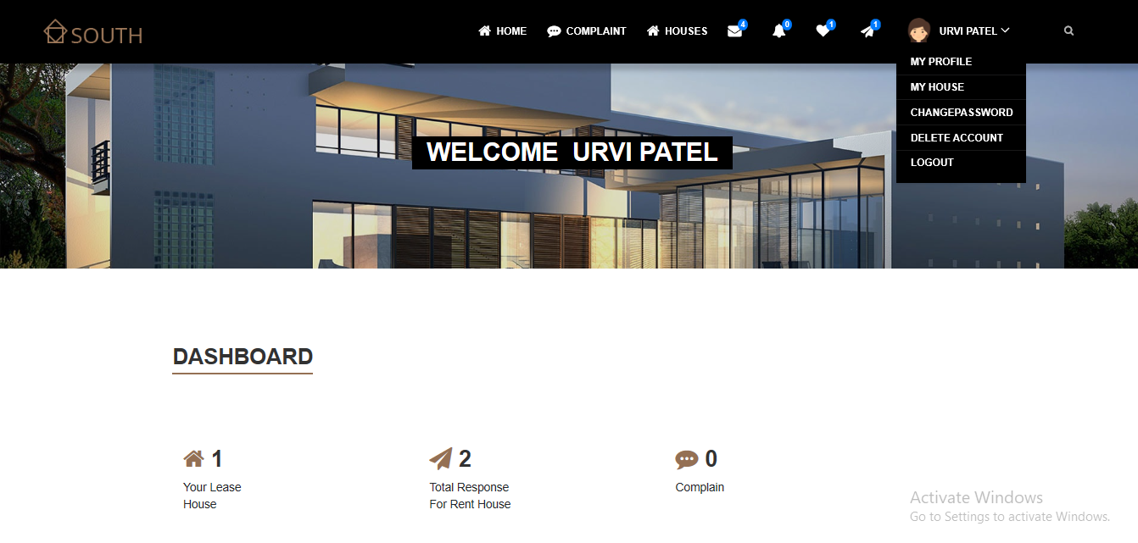

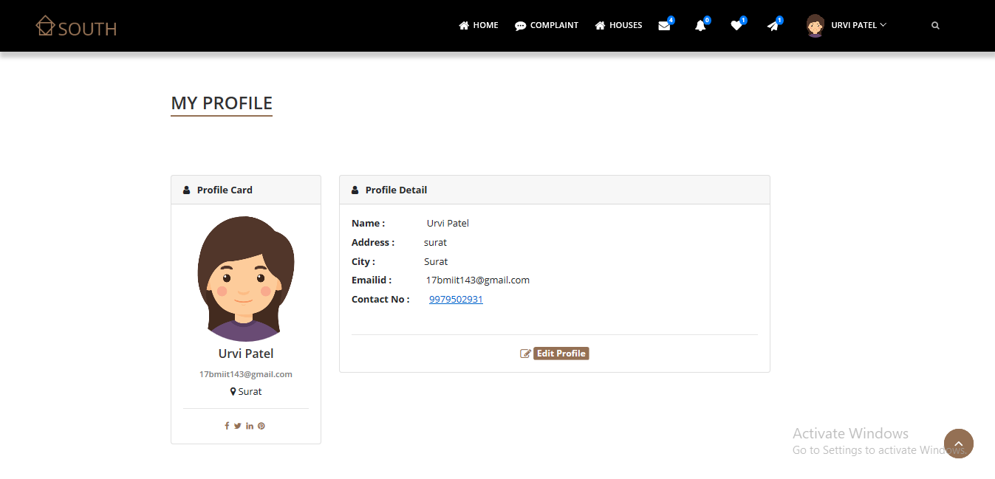

* 1. 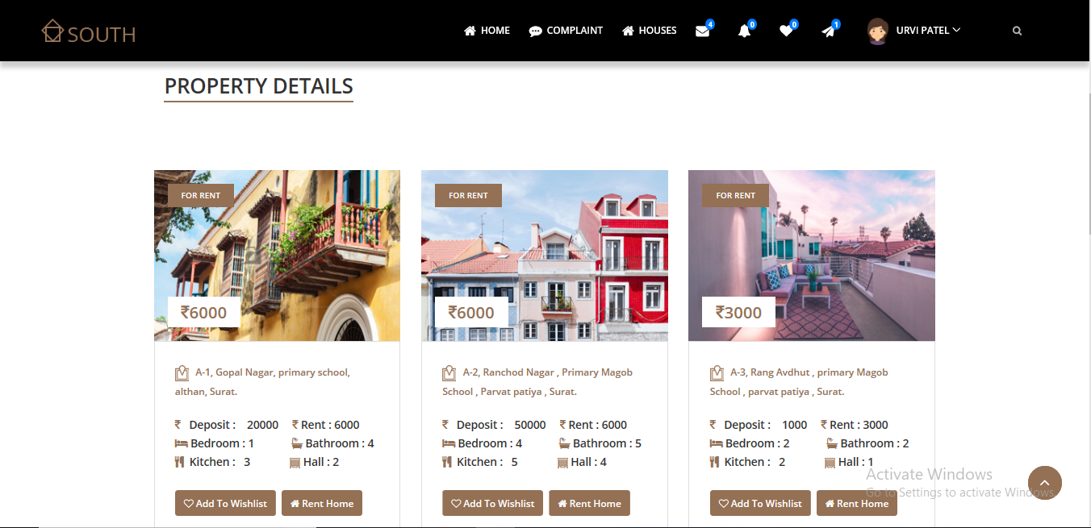**Property Detail**
  2. **Send Request for rent property**

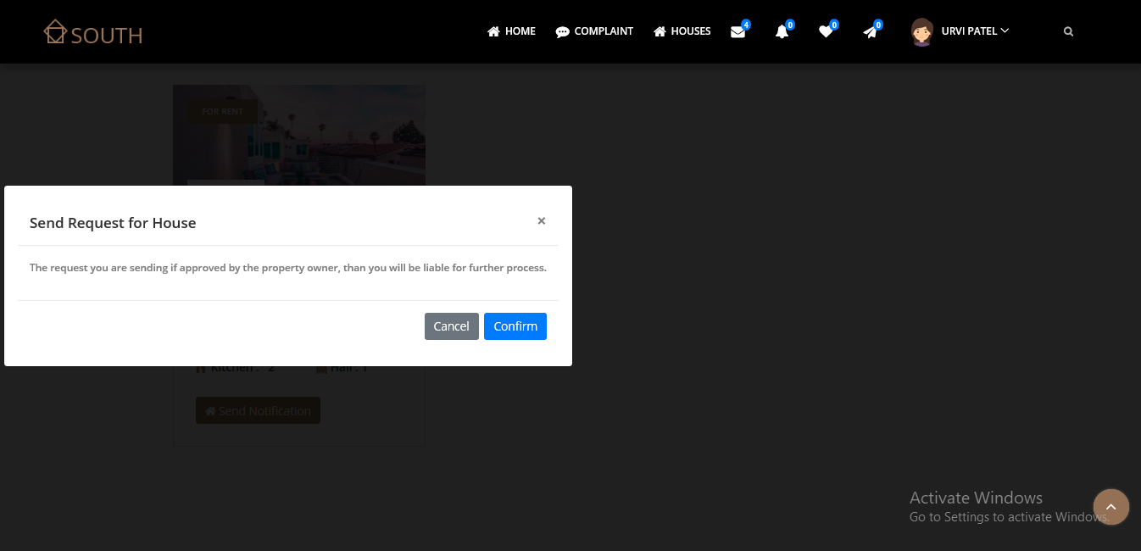

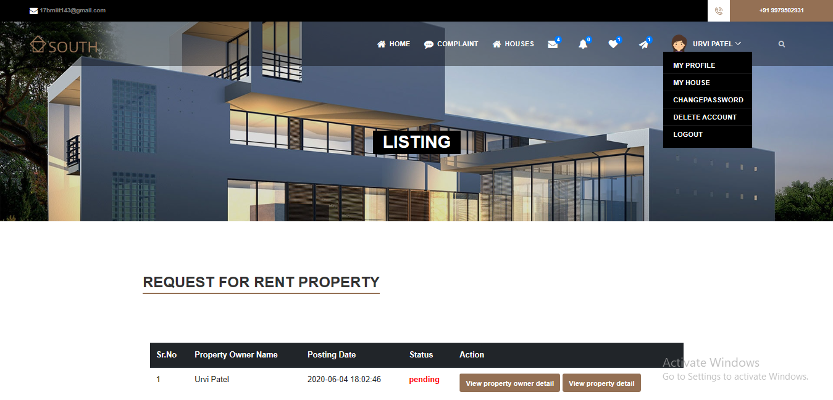

* 1. 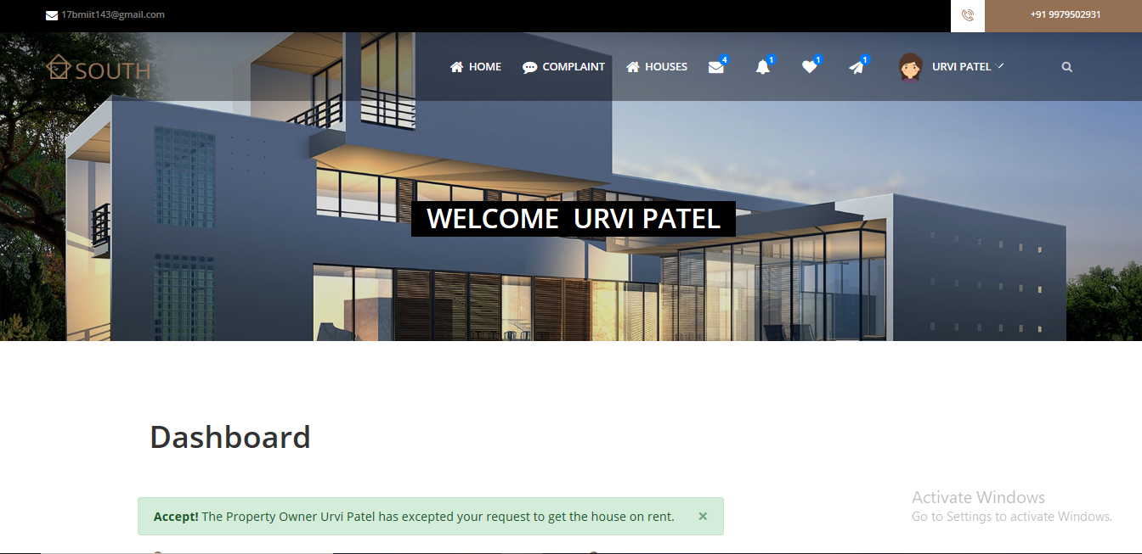**Accept Notification for Rent Property**
  2. **Accept terms & condition for rent property**

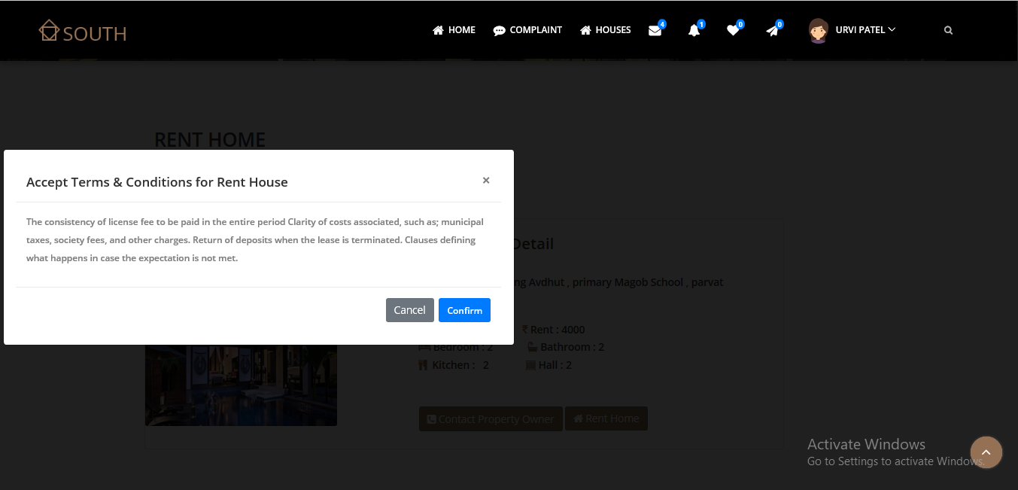

* 1. 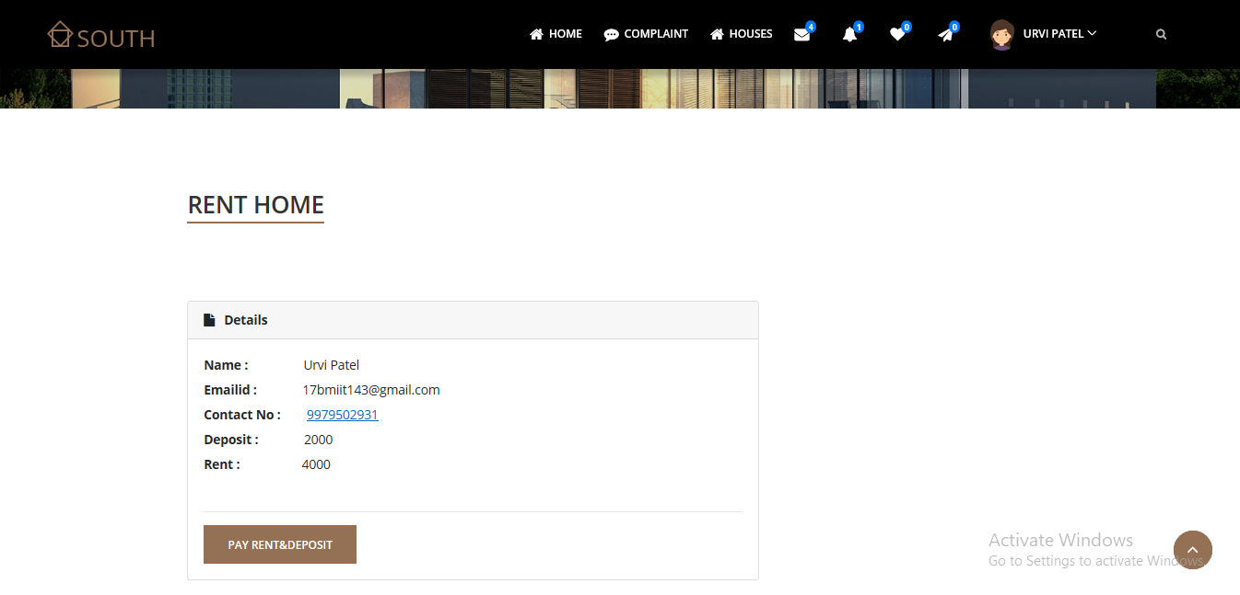**Pay Rent & Deposit**

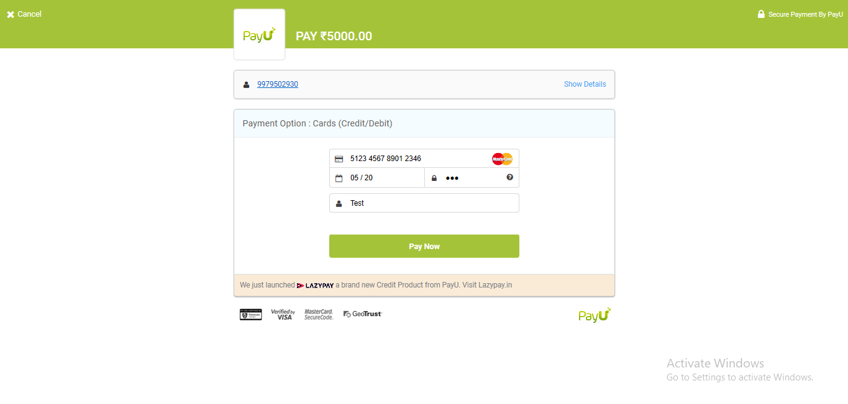

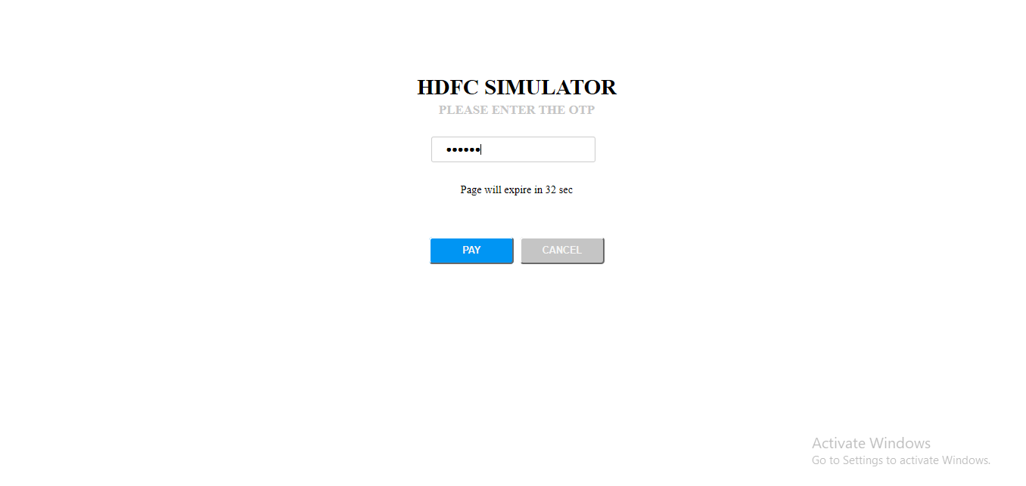

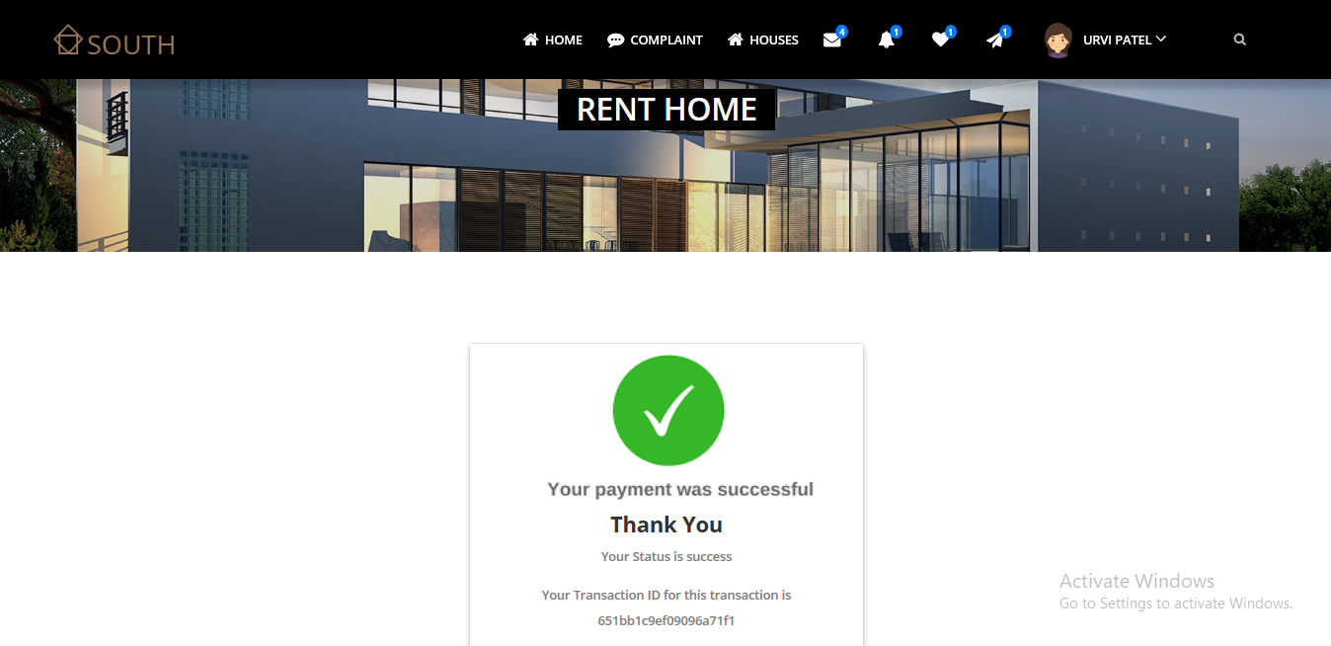

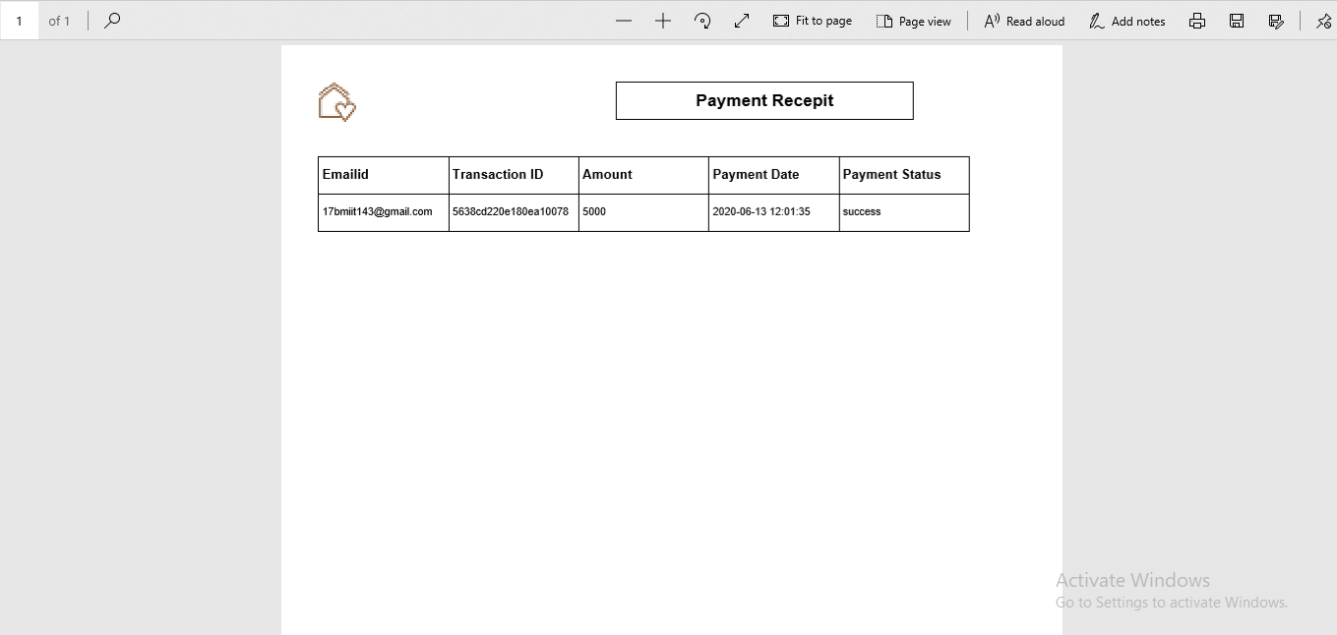

* 1. 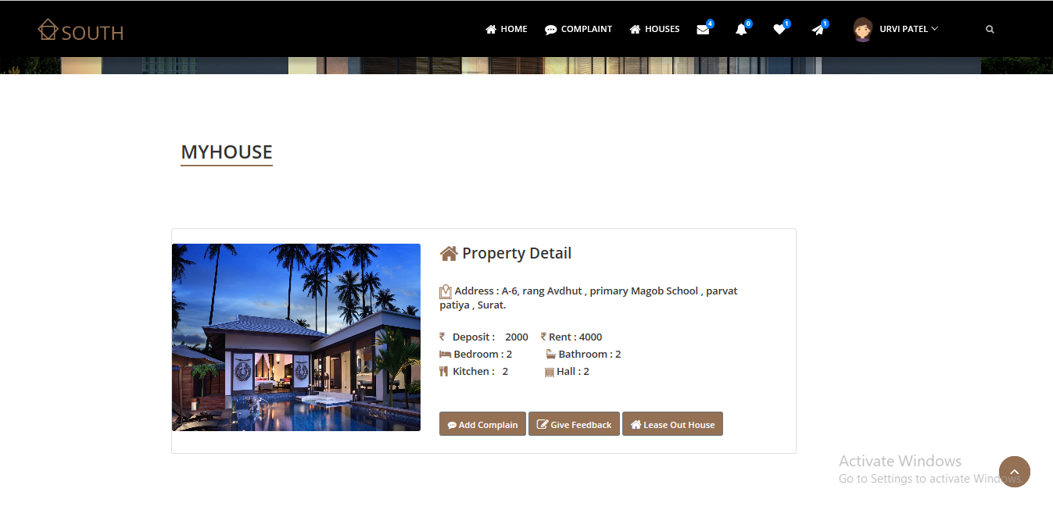**My House Detail**
  2. **Add Complain for rent property**

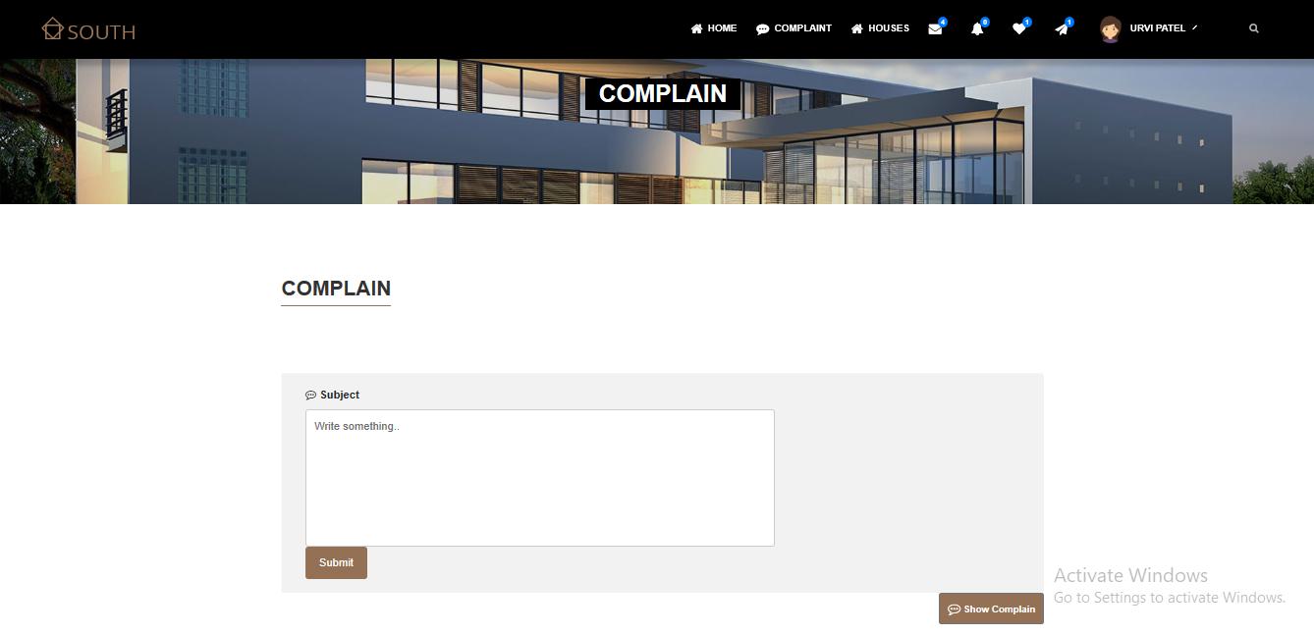

* 1. **Feedback**

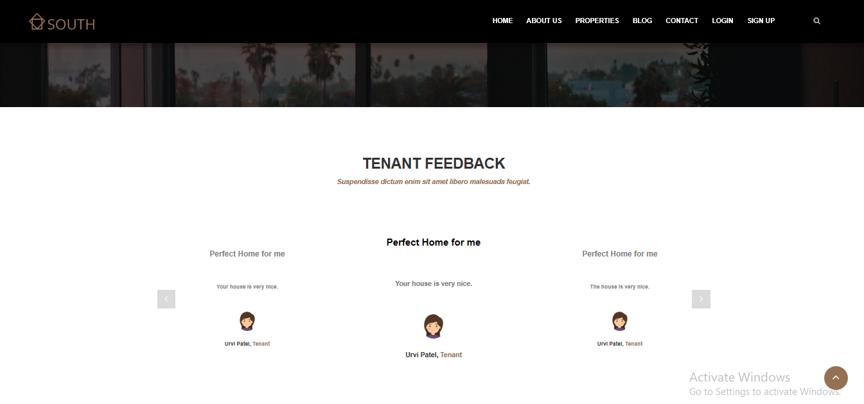

* 1. **Chat Message**

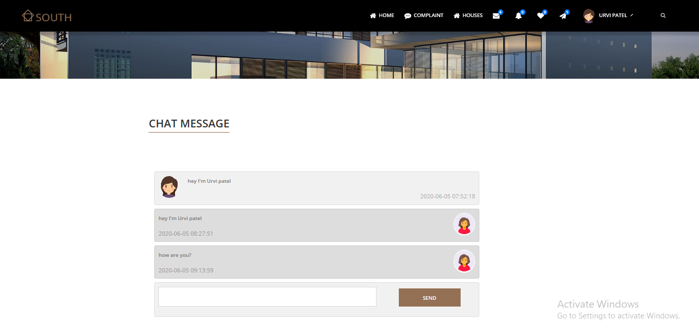

* 1. 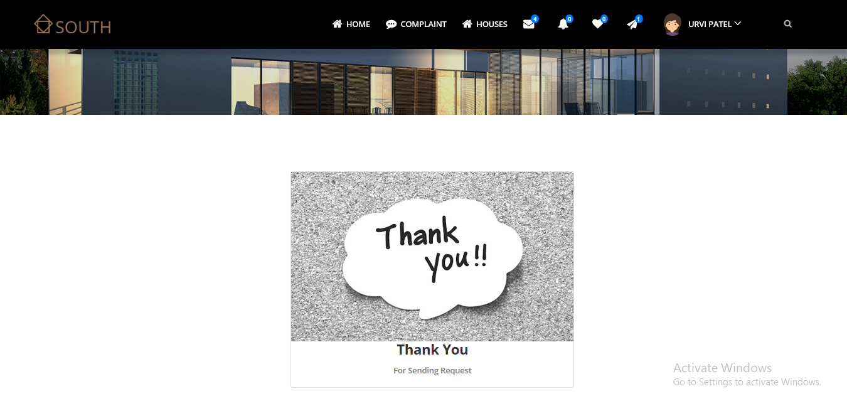**Thank you Page**

1. **Testing**
   1. **Test Cases**

|  |  |  |  |  |  |
| --- | --- | --- | --- | --- | --- |
| **Test Case Number** | **Description** | **Input Value** | **Expected Output** | **Actual Output** | **Result** |
| TC1 | Login | Username = ”1234 ” Password=”***” | Error message | Login | Fail |
| TC2 | Login | Username= dreamhouse@gmail.com Password=”********” | Redirect to Successful Page | Login | Pass |

|  |  |  |  |  |
| --- | --- | --- | --- | --- |
| **Test Case Number** | **Input Value** | **Expected Output** | **Actual Output** | **Result** |
| TC1 | First name=” ” | Error message | Not Accept | Fail |
| TC2 | First name=”Urvi ” | Accept | Accept | Pass |
| TC3 | Email =” ” | Error message | Not Accept | Fail |
| TC4 | Email =”dreamhouse@gmail.com” | Accept | Accept | Pass |
| TC5 | Phone number=”1222567890” | Error message | Not Accept | Fail |
| TC6 | Phone number=”9979587536” | Accept | Accept | Pass |
| TC7 | Password=” ” | Error message | Not Accept | Fail |
| TC8 | Password=”*******” | Accept | Accept | Pass |
| TC9 | Confirm password=” ” | Error message | Not Accept | Fail |
| TC10 | Confirm Password=”*******” | Accept | Accept | Pass |

* 1. **Validation** 
     1. 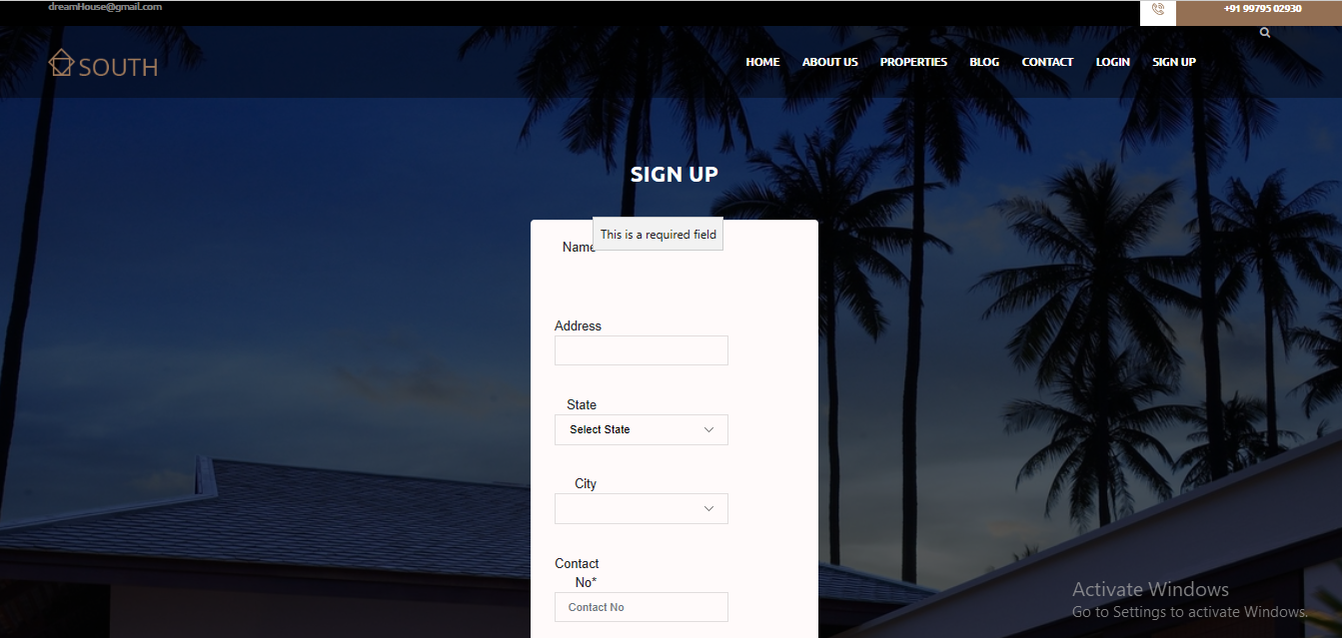**Registration Validation**

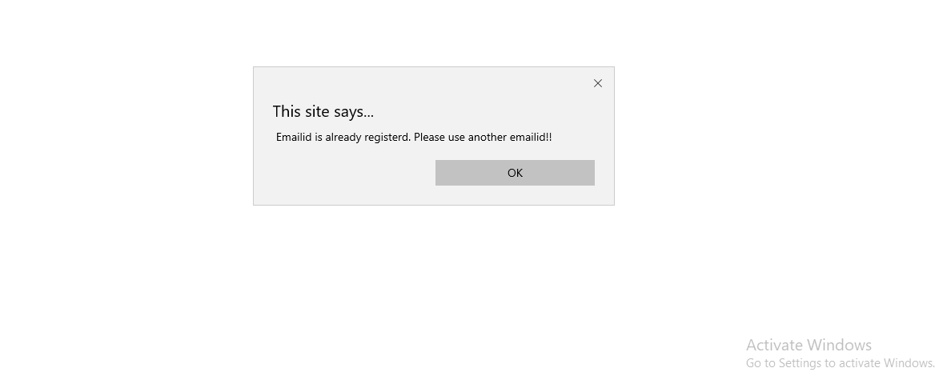

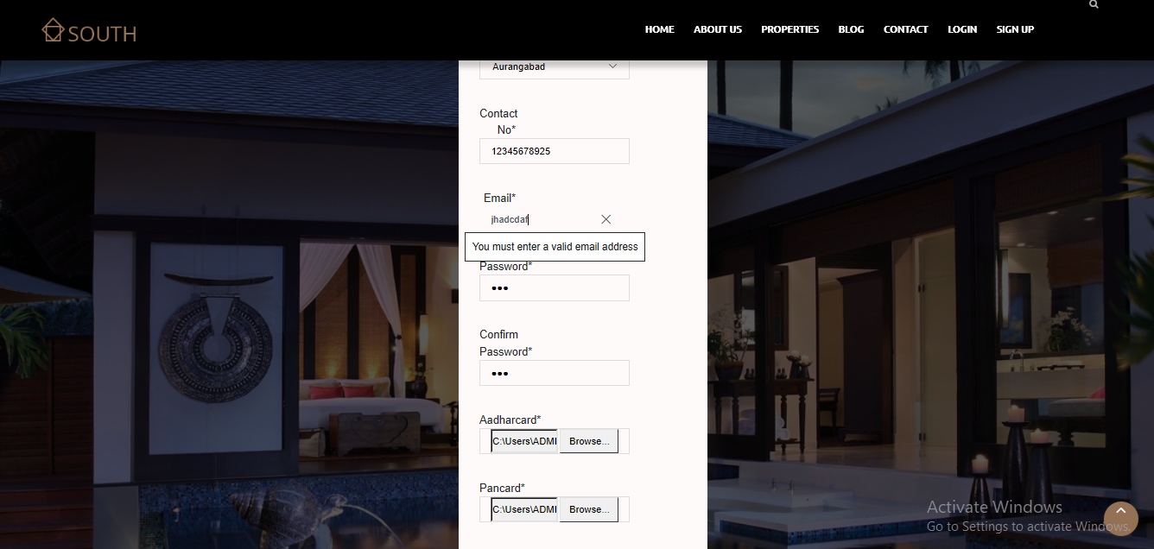

* + 1. 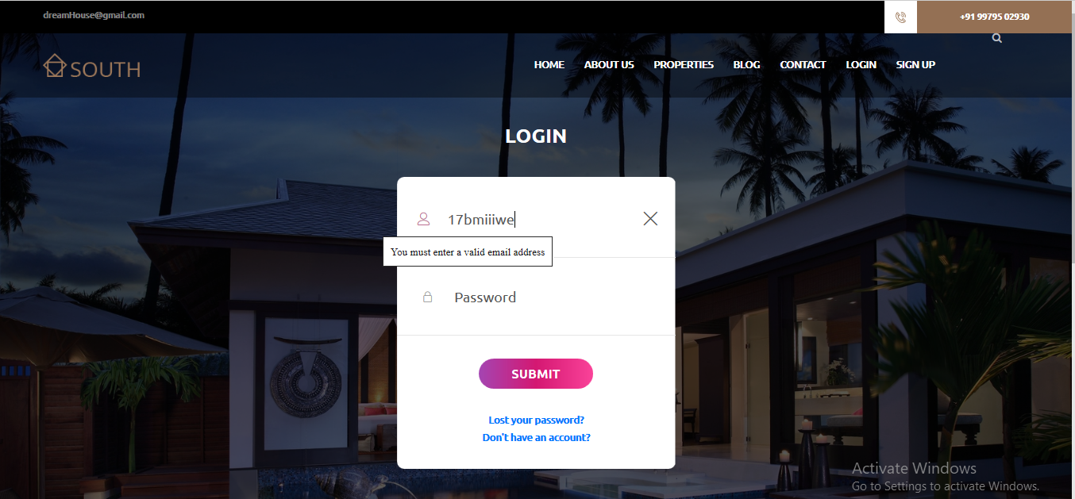**Login Validation**

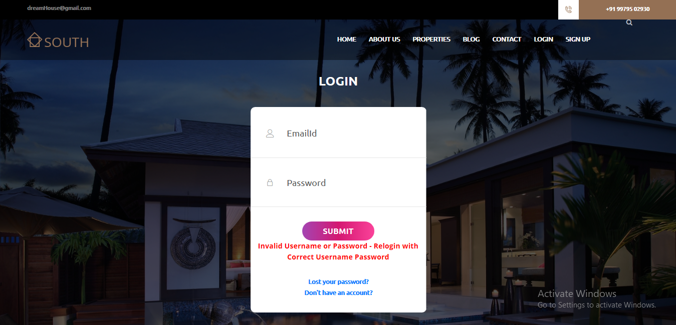

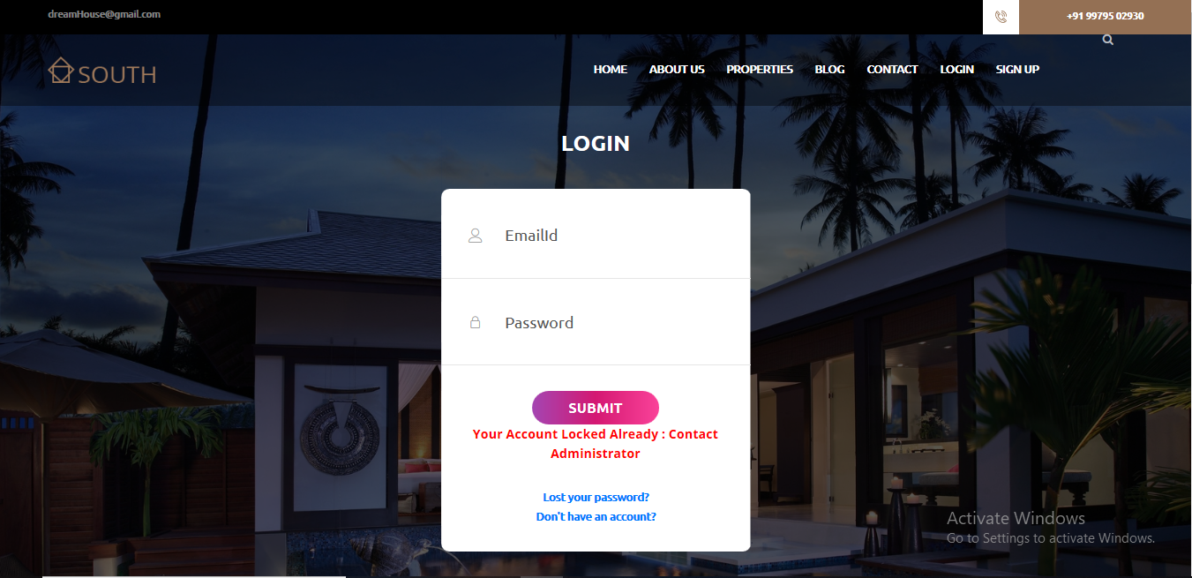

* + 1. **Phone number Validation**

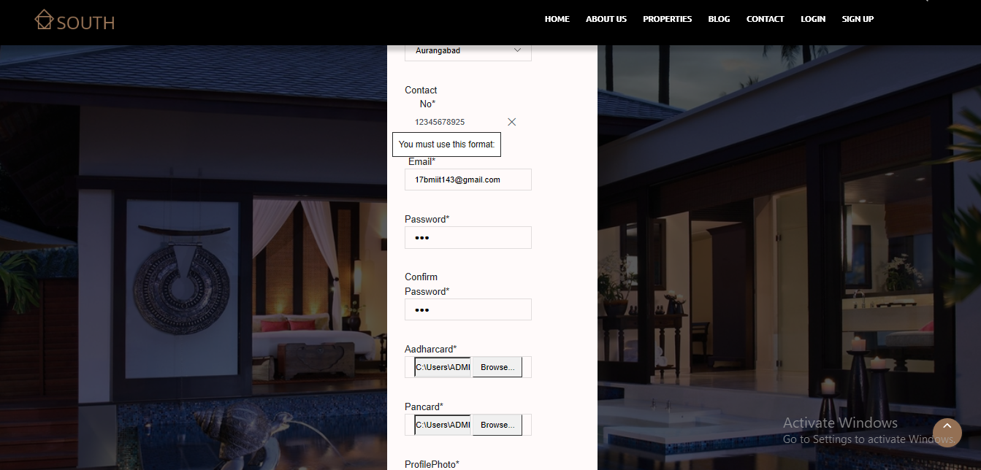

* + 1. **Change Password**

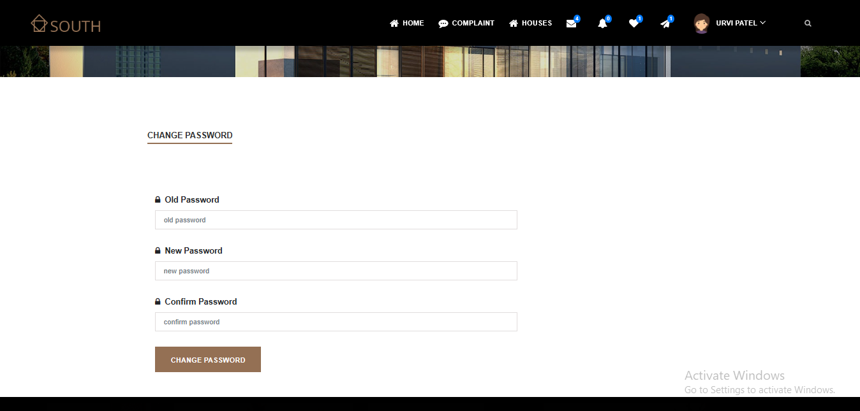

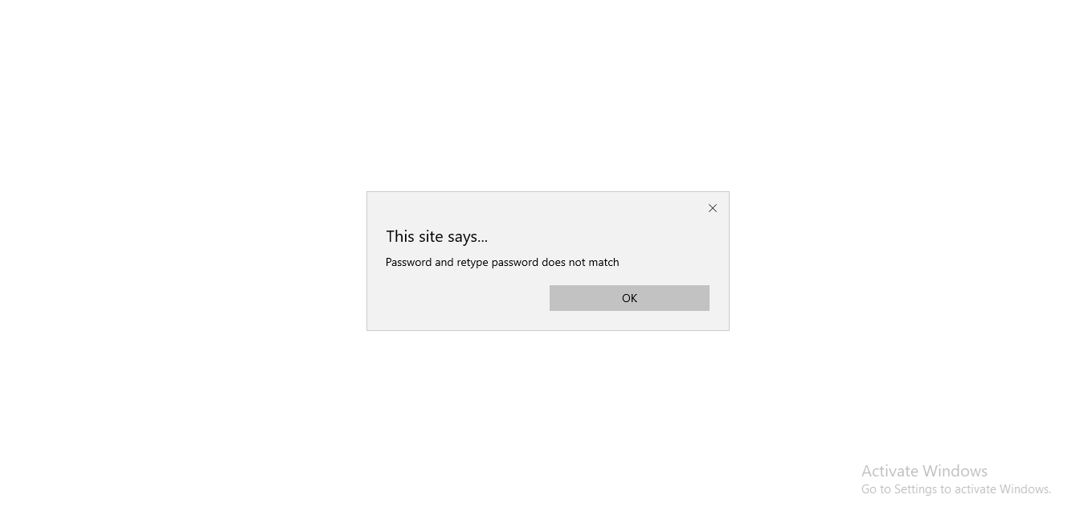

* + 1. **Forgot Password**

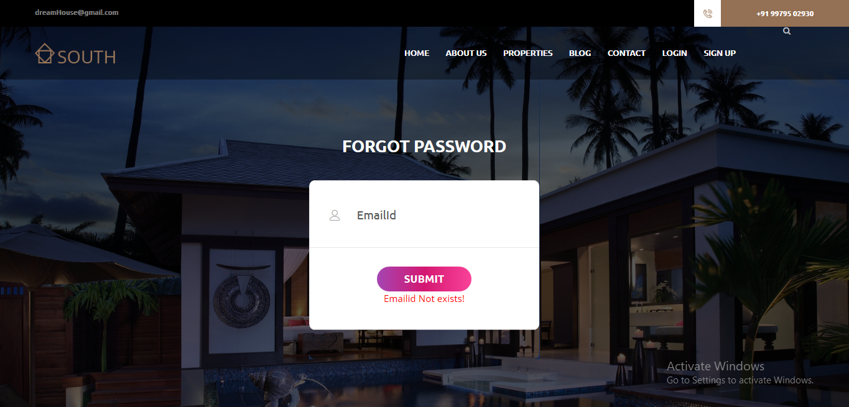

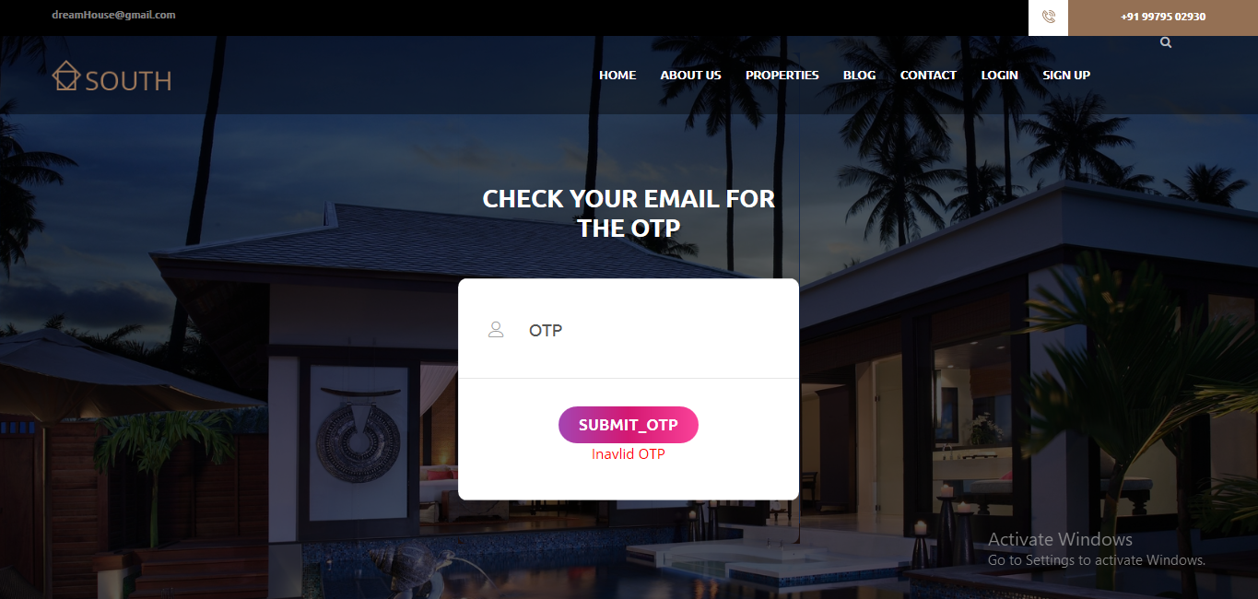

1. **Future Enhancement**

* Our system is specially designed for the property owner to give property on rent. But, in future we can add more features like manage agent and many more. We can also add the feature of live show property by which tenant can rent property without physically visiting the property.

1. **References/Bibliography**
   1. **References:**

[1] Steverholzner, the Complete Reference PHP, McGraw Hill.

[2] Steve Suehring, Tim Converse and Joyce Park, PHP6 and MySQL, Wiley India Pvt. Ltd.

[3] Singh Y., Malhotra R., Object oriented Software Engineering, PHI.

* 1. **Bibliography:**

[**http://www.here.com/**](https://www.bing.com/search?q=http%3A%2F%2Fwww.here.com%2F&form=PRINEN&pc=UE00&httpsmsn=1&msnews=1&refig=78607e943a904f02a37e880f02a3985b&sp=-1&pq=http%3A%2F%2Fwww.here.com%2F&sc=1-20&qs=n&sk=&cvid=78607e943a904f02a37e880f02a3985b)

[**http://stackoverflow.com/**](https://www.bing.com/search?q=http%3A%2F%2Fstackoverflow.com%2F&form=PRINEN&pc=UE00&httpsmsn=1&msnews=1&refig=03f658d25c4d44ecbcb9e98fd30deb70&sp=-1&pq=http%3A%2F%2Fstackoverflow.com%2F&sc=2-25&qs=n&sk=&cvid=03f658d25c4d44ecbcb9e98fd30deb70)

[**https://www.getbootstarp.com/**](https://www.bing.com/search?q=https%3A%2F%2Fwww.getbootstarp.com%2F&form=PRINEN&pc=UE00&httpsmsn=1&msnews=1&refig=7544b9609212472a8f81e429fb64afe2&sp=-1&pq=https%3A%2F%2Fwww.getbootstarp.com%2F&sc=0-29&qs=n&sk=&cvid=7544b9609212472a8f81e429fb64afe2)

[**https://www.fpdf.org/**](https://www.bing.com/search?q=https%3A%2F%2Fwww.fpdf.org%2F&form=PRINEN&pc=UE00&httpsmsn=1&msnews=1&refig=3c895eb28f9243cdb817115f3e516406&sp=-1&pq=https%3A%2F%2Fwww.fpdf.org%2F&sc=0-21&qs=n&sk=&cvid=3c895eb28f9243cdb817115f3e516406)